**DEPARTMENT OF COMPUTER SCIENCE AND**

**ENGINEERING**

**LAB MANUAL**

**Academic Year: 2017-17 ODD SEMESTER**

|  |  |  |
| --- | --- | --- |
| **Programme (UG/PG)** | **:** | **UG** |
| **Semester** | **:** | **V** |
| **Course Code** | **:** | **15IT303J** |
| **Course Title** | **:** | **Computer Networks** |

*Prepared By*

**RAVI SHANKAR KUMAWAT**

**RA1511003010978**

***( Department of Computer Science and Engineering*)**



**FACULTY OF ENGINEERING AND TECHNOLOGY**

**SRM UNIVERSITY**

(Under section 3 of UGC Act, 1956) SRM Nagar, Kattankulathur- 603203 Kancheepuram District

**B.Tech.,/CSE Regulation: 2015**

**Sub.Code/Sub.Name : 15IT303J/Computer Networks**

**Course Incharge : Mr.S.Pradeep.**

**SRM University**

**Department of Information Technology**

**Rubrics for Grading 15IT303J – Computer Networks**

|  |  |  |  |  |  |
| --- | --- | --- | --- | --- | --- |
| **Experiment Component** | **Max. Marks** | **Grading Rubrics** | | | |
| AIM | 1 | Aim are written clearly and well defined **[1 Marks]** | | | |
| Physical Configuration | 3 | Completeness of Physical component placed and interconnection in Packet Tracer **[3 Marks]** | Completeness of physical components placed and incomplete interconnection in Packet Tracer  **[2 Marks]** | | Incomplete physical component placed and interconnection in Packet Tracer **[1 Marks]** |
| Logical Configuration | 3 | Completeness of Logical configuration and all interfaces configured in Packet Tracer **[3 Marks]** | Completeness of Logical configuration and incomplete interfaces configured in Packet Tracer  **[2 Marks]** | | Incomplete Logical configuration and all interfaces configured in Packet Tracer **[1 Marks]** |
| Analysis | 2 | All configurations are analyzed successfully **[2 Marks]** | | All configurations are partially analyzed  **[1 Marks]** | |
| Result | 1 | All configurations are successfully tested **[1 Marks]** | | | |

Name: Reg:

Class: Branch:

|  |  |  |  |  |  |
| --- | --- | --- | --- | --- | --- |
| Expt. No | Date of expt. | Title of Experiment | Page No. | Marks | Signature |
| 1 | 04-07-17 | Introduction to packet tracer and routers  a)LAN using routers  b)LAN using routers and switches |  |  |  |
| 2 | 11-07-17 | Connecting routers using serial port. |  |  |  |
| 3 | 19-07-17 | LAN Configuration using straight  through and cross over cables |  |  |  |
| 4 | 26-07-17 | Subnetting  a)Class C  b)Class B  c)Class A |  |  |  |
| 5 | 02-08-17 | IP Addressing and sub netting (VLSM) |  |  |  |
| 6 | 09-08-17 | Topologies  a)Bus  b)Star  c)Ring  d)Mesh |  |  |  |
| 7 | 18-08-17 | Basic Router Configuration ( Creating  Passwords, Configuring Interfaces) |  |  |  |
| 8 | 04-09-17 | RIP v1 and RIP v2 |  |  |  |
| 9 | 11-09-17 | Summarization |  |  |  |
| 10 | 19-09-17 | EIGRP Authentication and Timers |  |  |  |

**INDEX**

**EXPERIMENT:-1(a)**

**ROUTERS**

**AIM:-** connect two devices with a router.

**PROCEDURE:**

Step1: Open packet tracer.

Step2: Click on devices and place the PC1 on the console and place another PC2 on the same console.

Step3: Click on the router and place a router on the console.

Step4: Click on the dotted wire and connect the device and router and another pc with the same dotted wire. The dotted wire shows red.

Step5: Go to the PC1 and click on the desktop tab and set the IP address, gateway and subnet mask for the PC.

Step6: Double click on the router and click on config tab in newly opened window and select on fastethernet0/0 and set the IP address, mask as the gateway and mask of the PC connected via the fastethernet0/0 port, set the port status ON and type no shutdown in the CLI tab. The connection should change to green.

Step7: Repeat the same procedure for PC2.

Step8: Now go to the PC1, then cmd and type the IP address of the PC2 and check whether it pings or not.

**CLI:-**

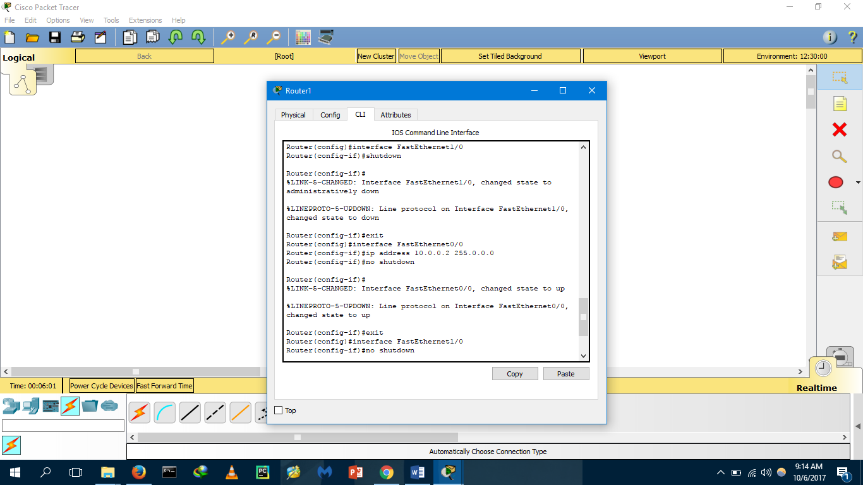

**DIAGRAM:**

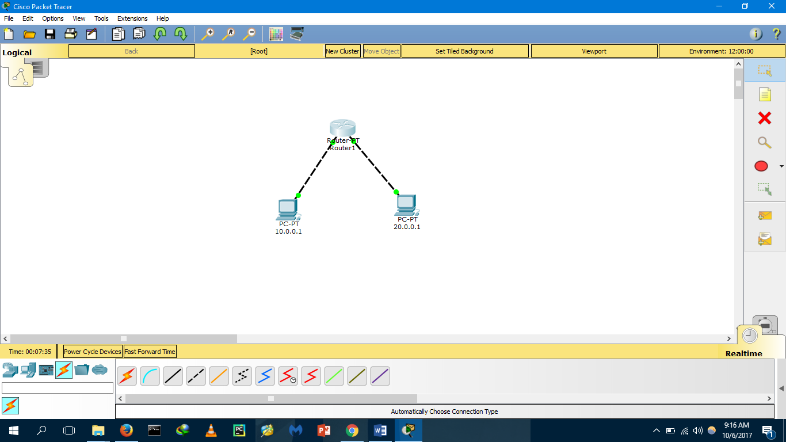

**OUTPUT:**

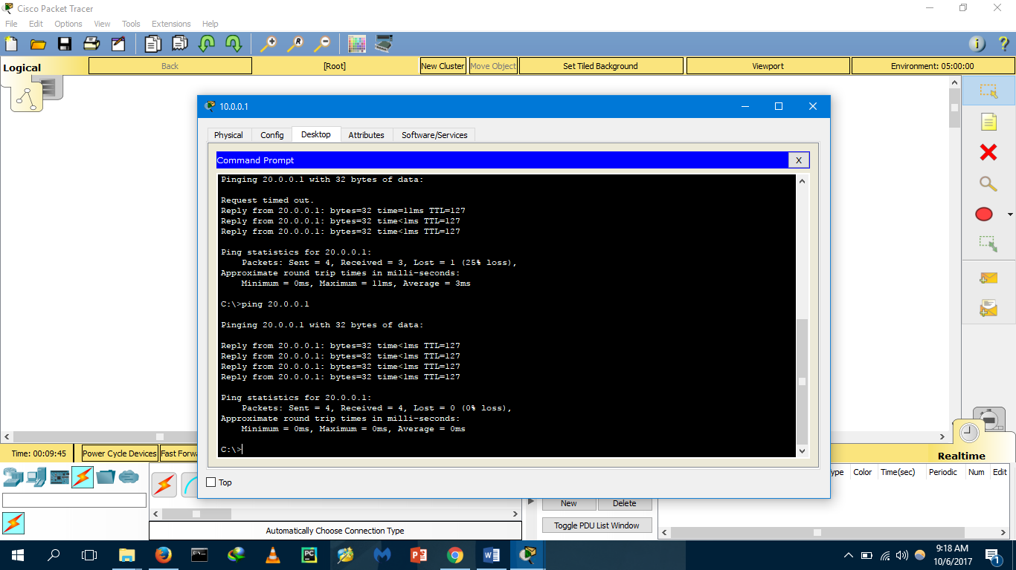

**RESULT:** The connection to the PCs established successfully using router.

**EXPERIMENT:-1(b)**

**CONNECTION OF PCs THROUGH SWITCHES**

**AIM:** To connect devices with a router using switches.

**PROCEDURE:**

Step1: Open packet tracer.

Step2: Click on devices and place the PC1 on the console and place another PC2 on the same console, repeat the same for PC3 and PC4.

Step3: Click on the router and place a router on the console and click on switches and hubs and add two switches.

Step4: Click on the wires tab and connect the PCs, switches and router as given in the diagram. The connecting wire shows red.

Step5: Go to the PC1 and click on the desktop tab and set the IP address, gateway and subnet mask for the PC repeat the same for PC2 giving same gateway as PC1.

Step6: Double click on the router and click on config tab in newly opened window and select on fastethernet0/0 and set the IP address, mask as the gateway and mask of the PC connected via the fastethernet0/0 port, set the port status ON and type no shutdown in the CLI tab. The connection should change to green.

Step7: Repeat the same procedure for PC3 and PC4 and connect them using the router.

Step8: Now go to the PC1, then cmd and type the IP address of the PC3 and check whether it pings or not.

**CLI:**

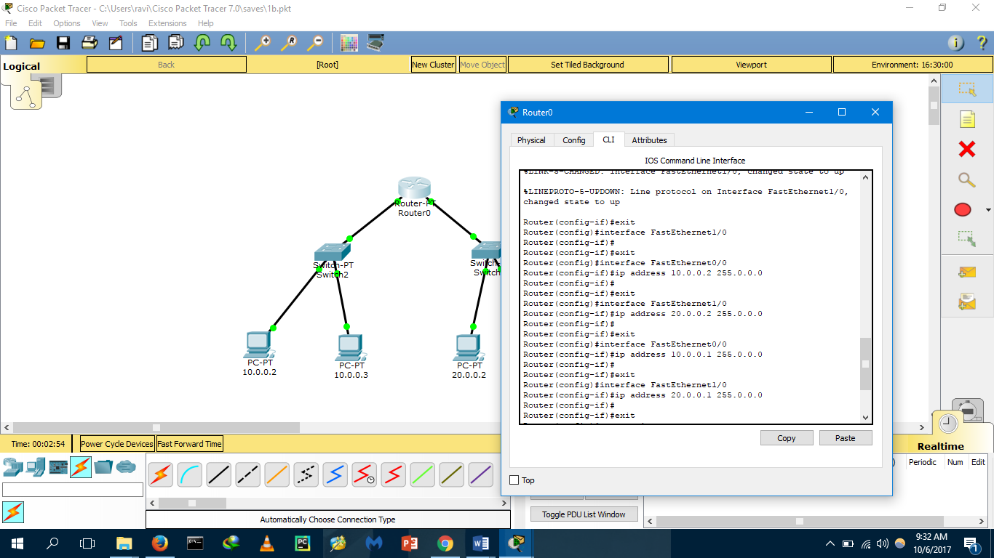

**DIAGRAM:**

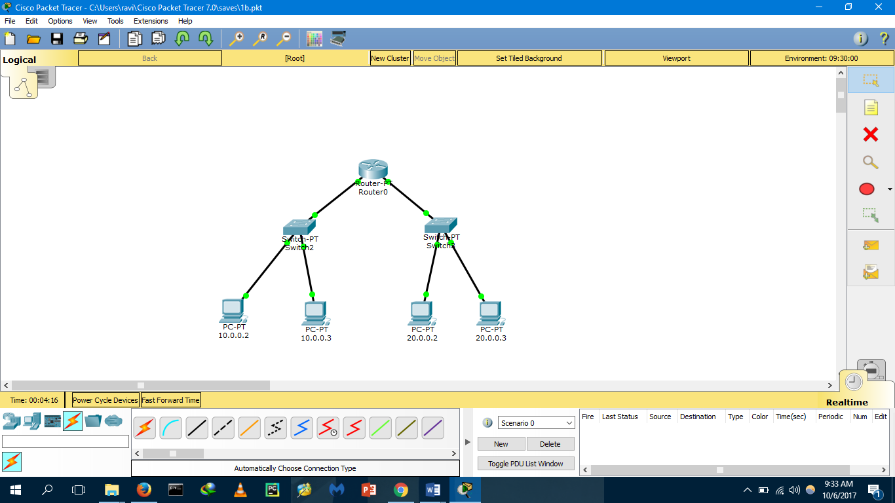

**OUTPUT:**

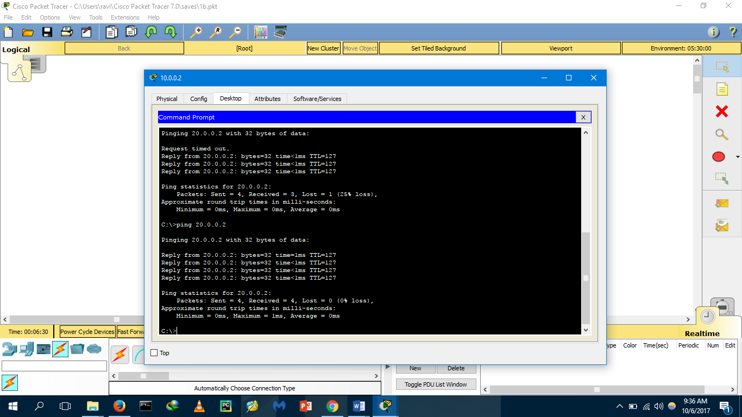

**RESULT:** The connection to the PCs established successfully using router and switches.

**EXPERIMENT:-2**

**CONNECTION OF ROUTERS WITH SERIAL WIRE**

**AIM :-**To connect two routers with serial connection.

**PROCEDURE :-**

Step1: Open packet tracer.

Step2: Click on devices and place the PC1 on the console and place another PC2 on the same console, repeat the same for PC3 and PC4.

Step3: Click on the router and place two routers on the console and click on switches and hubs and add two switches.

Step4: Click on the connections tab and connect the PCs, switches and router with serial DCE connection as given in the diagram. The connecting wire shows red.

Step5: Go to the PC1 and click on the desktop tab and set the IP address, gateway and subnet mask for the PC repeat the same for PC2 giving same gateway as PC1.

Step6: Double click on the router1 and click on config tab in newly opened window and select on fastethernet0/0 and set the IP address, mask as the gateway and mask of the PC connected via the fastethernet0/0 port, set the port status ON and type the following commands in the CLI tab. The connection should change to green.

Step7: Repeat the same procedure for PC3 and PC4 and connect them using the router2.

Step8: Now go to the PC1, then cmd and type the IP address of the PC3 and check whether it pings or not.

**CLI:**

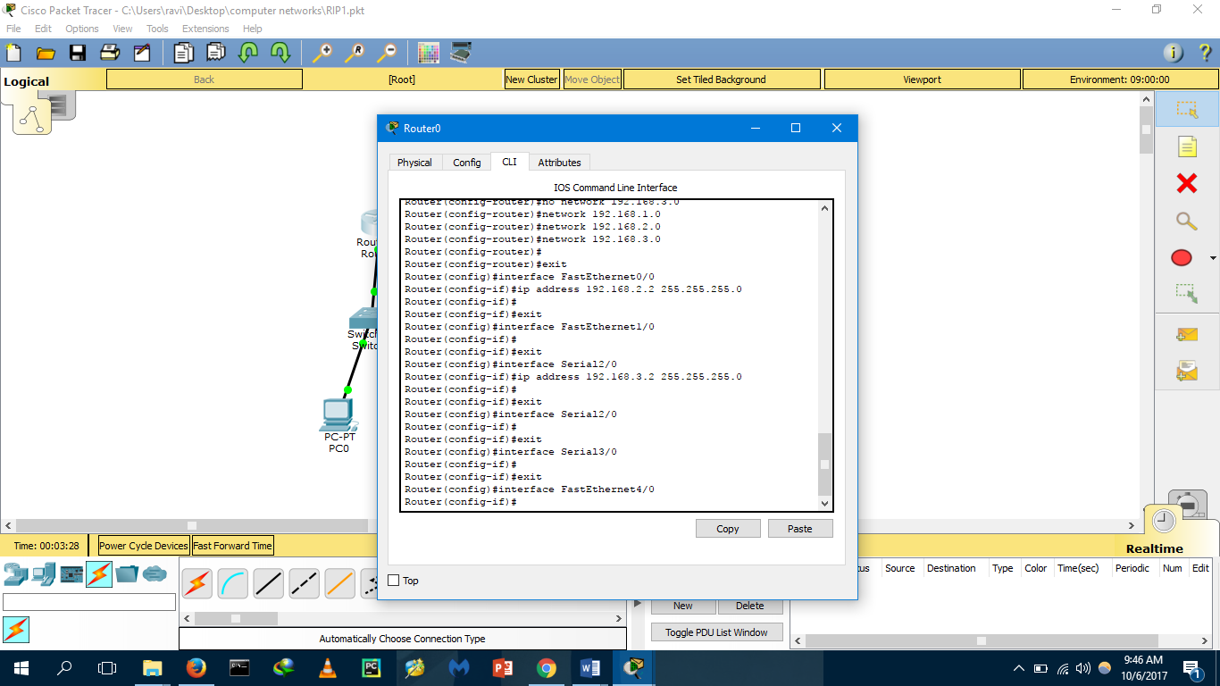 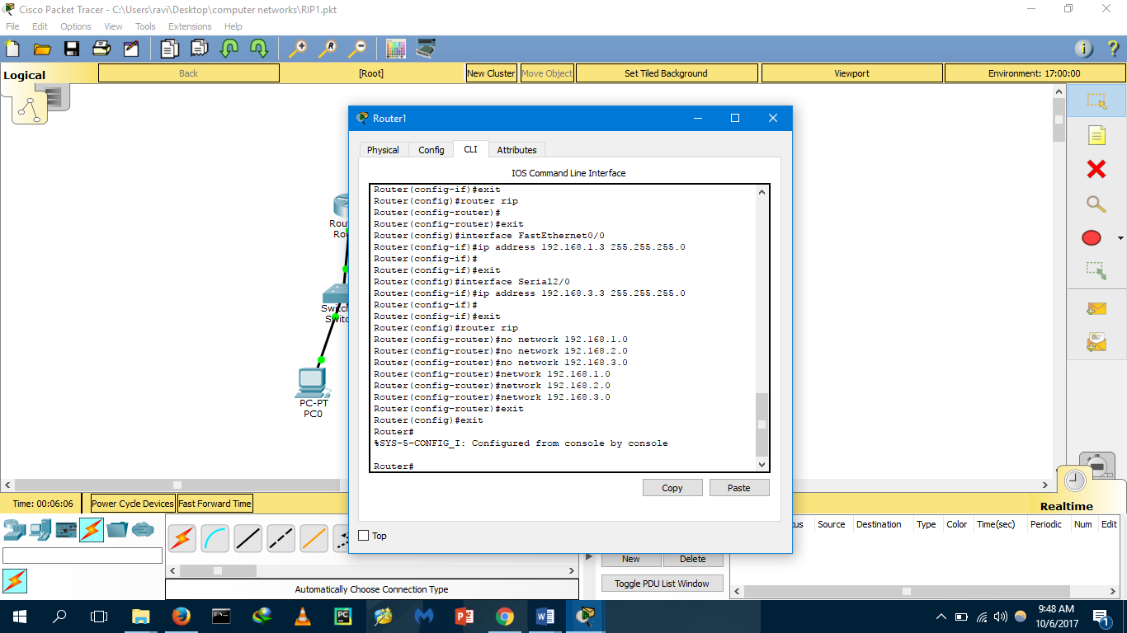

**DIAGRAM:**

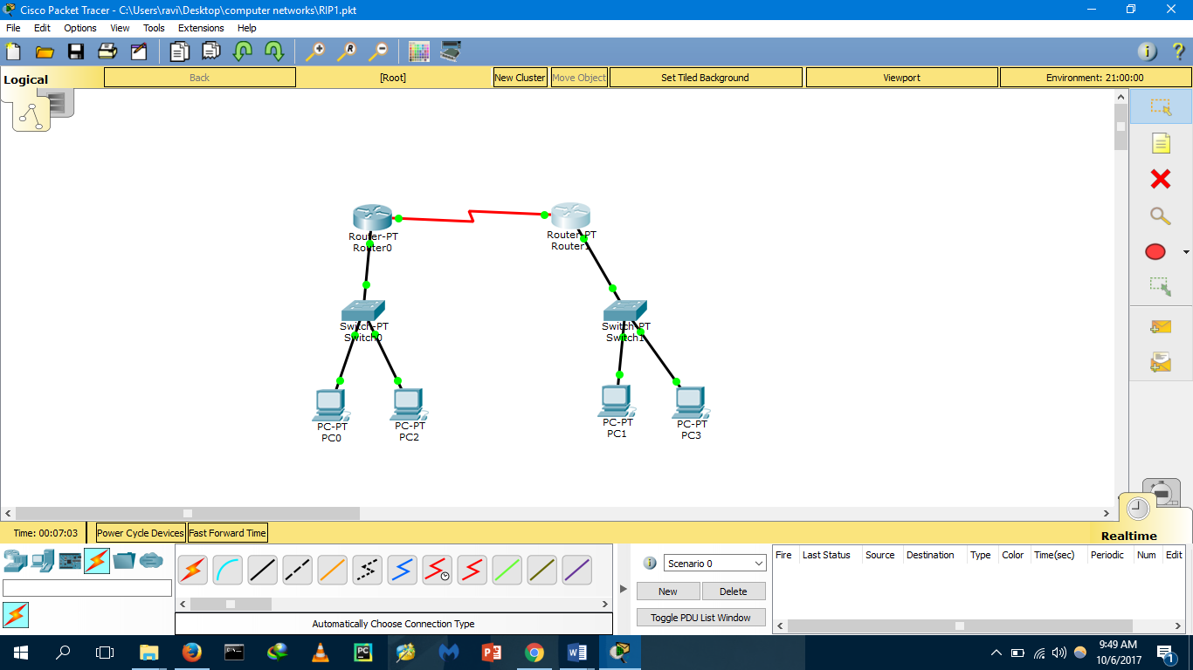

**OUTPUT:**

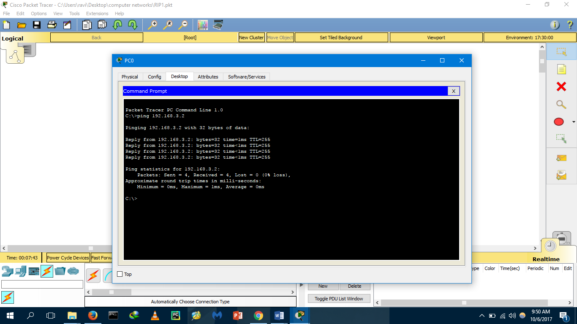

**RESULT:-** The connection to the PCs established successfully using router and switches.

**EXPERIMENT:-3a**

**CONNECTION OF ROUTERS WITH CROSS WIRE**

**AIM: To** configure LAN using straight through and copper crossover wires.

**PROCEDURE:**

Step1: Open packet tracer.

Step2: Click on devices and place the PC1 on the console and place another PC2 on the same console, repeat the same for PC3 and PC4.

Step3: Click on the router and place two routers on the console and click on switches and hubs and add two switches.

Step4: Click on the connections tab and connect the PCs, switches and router with copper crossover connection as given in the diagram. The connecting wire shows red.

Step5: Go to the PC1 and click on the desktop tab and set the IP address, gateway and subnet mask for the PC repeat the same for PC2 giving same gateway as PC1.

Step6: Double click on the router1 and click on config tab in newly opened window and select on fastethernet0/0 and set the IP address, mask as the gateway and mask of the PC connected via the fastethernet0/0 port, set the port status ON and type the following commands in the CLI tab. The connection should change to green.

Step7: Repeat the same procedure for PC3 and PC4 and connect them using the router2.

Step8: Now go to the PC1, then cmd and type the IP address of the PC3 and check whether it pings or not.

**CLI:**

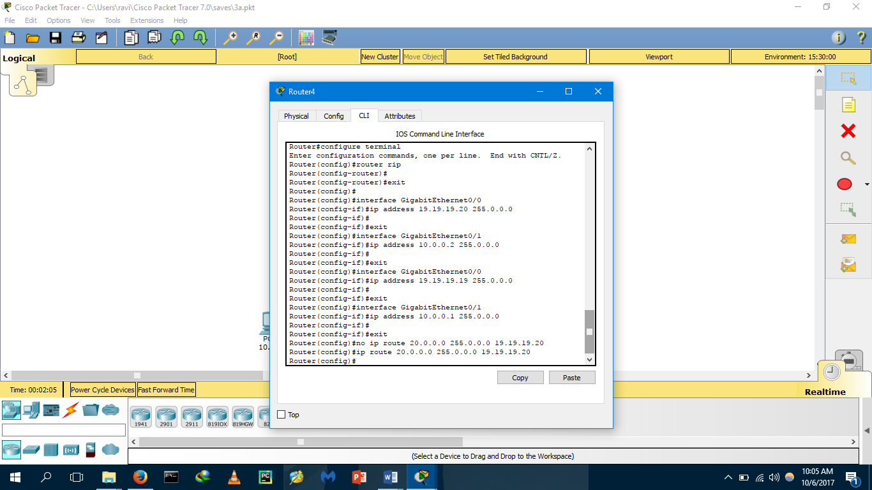 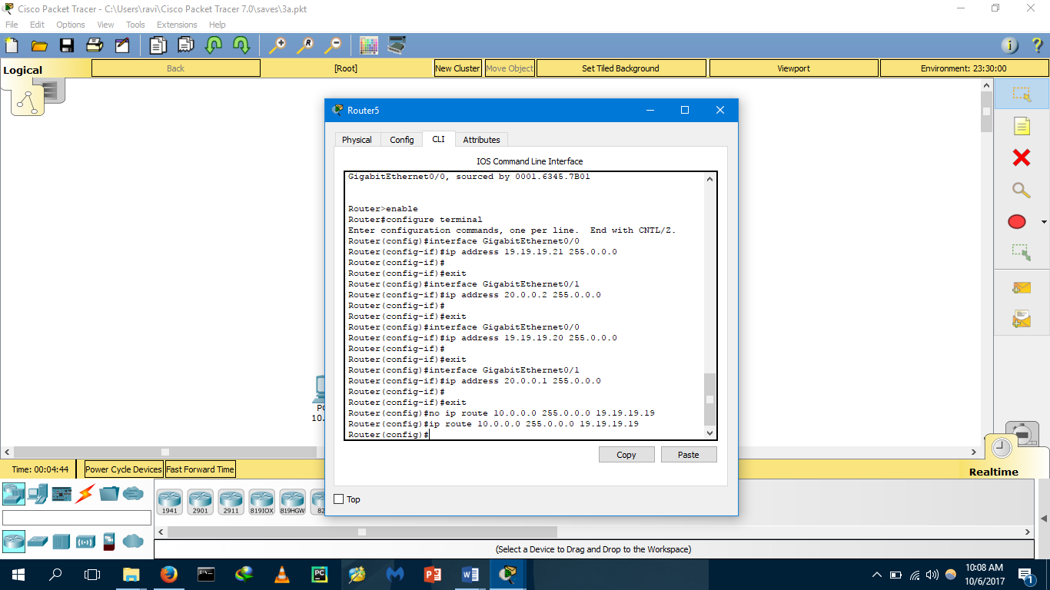

**DIAGRAM:**

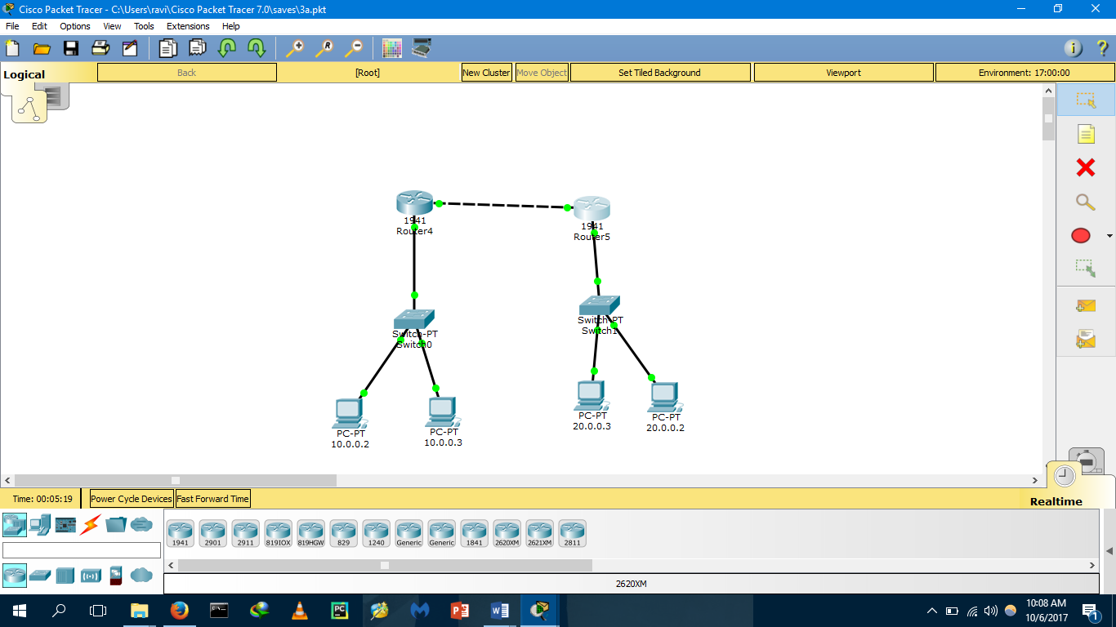

**OUTPUT:**

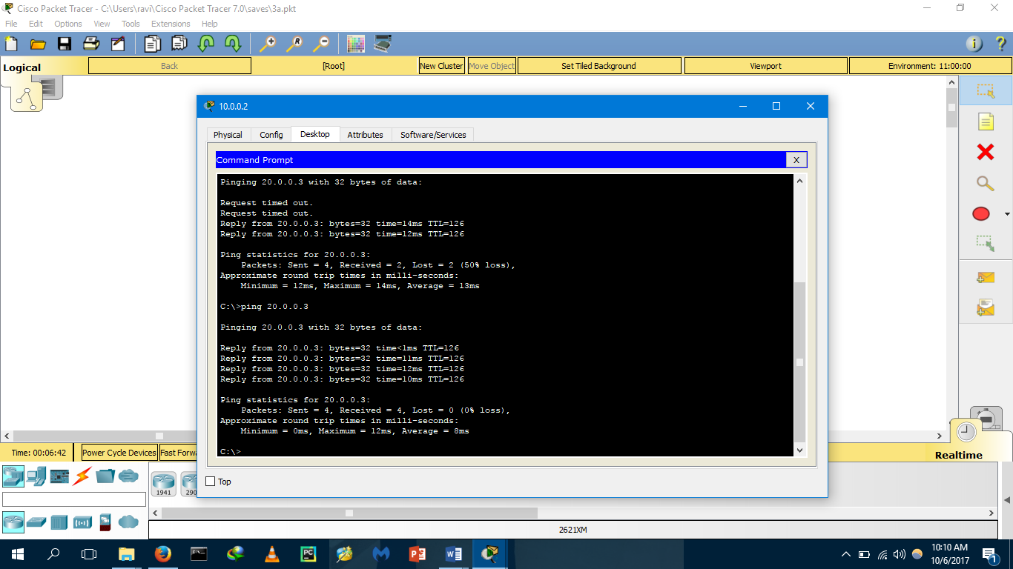

**RESULT:-** The LAN connection established successfully.

**EXPERIMENT:-3b**

**CONNECTING ROUTERS WITH FOUR SWITCHES**

**AIM:** To configure LAN using straight through and copper crossover wires and many switches.

**PROCEDURE:**

Step1: Open packet tracer.

Step2: Click on devices and place the PC1 on the console and place another PC2 on the same console, repeat the same for PC3,PC4,PC5-8.

Step3: Click on the router and place two routers on the console and click on switches and hubs and add two switches.

Step4: Click on the connections tab and connect the PCs, switches and router with copper crossover connection as given in the diagram. The connecting wire shows red.

Step5: Go to the PC1 and click on the desktop tab and set the IP address, gateway and subnet mask for the PC repeat the same for PC2 giving same gateway as PC1.Repeat same for PC3,PC4

And connect them with the router using switch.

Step6: Double click on the router1 and click on config tab in newly opened window and select on gigabitethernet0/0 and set the IP address, mask as the gateway and mask of the PC connected via the gigabitethernet0/0 port, set the port status ON and type the following commands in the CLI tab. The connection should change to green.

Step7: Repeat the same procedure for PC3 to PC8 and connect them using the router2.

Step8: Now go to the PC1, then cmd and type the IP address of the PC3 and check whether it pings or not.

**CLI:**

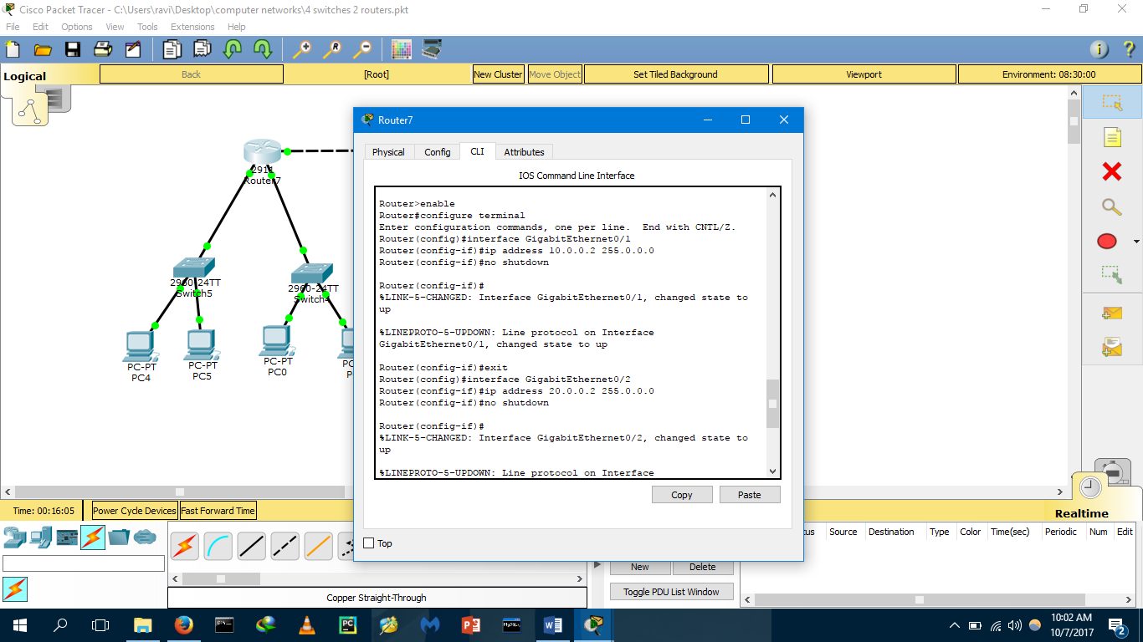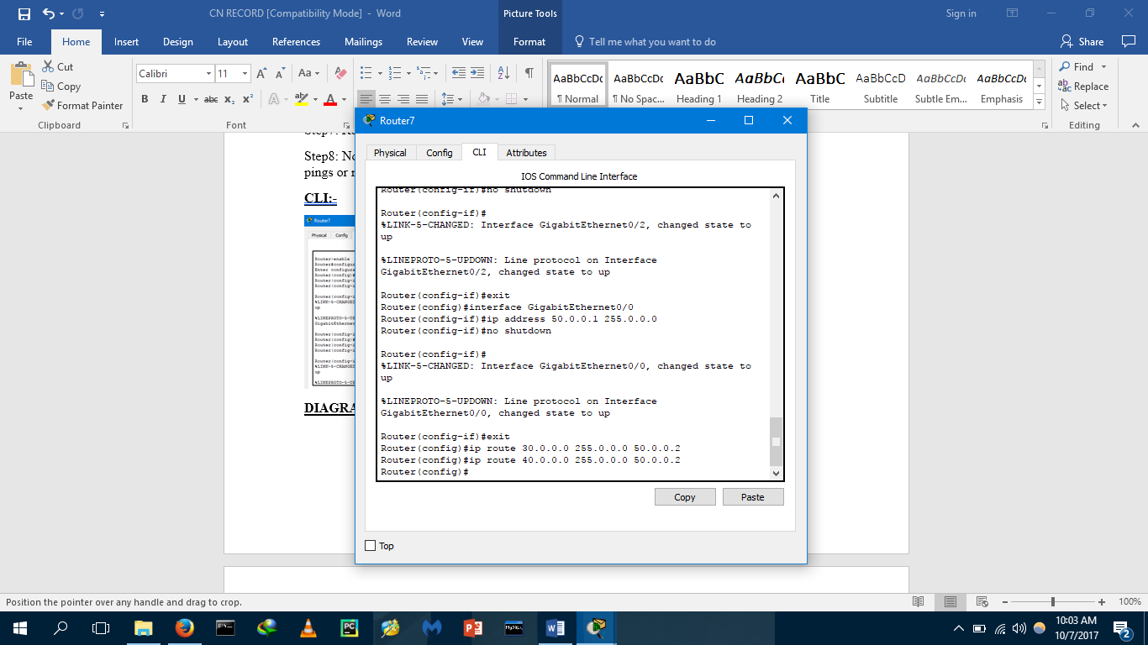

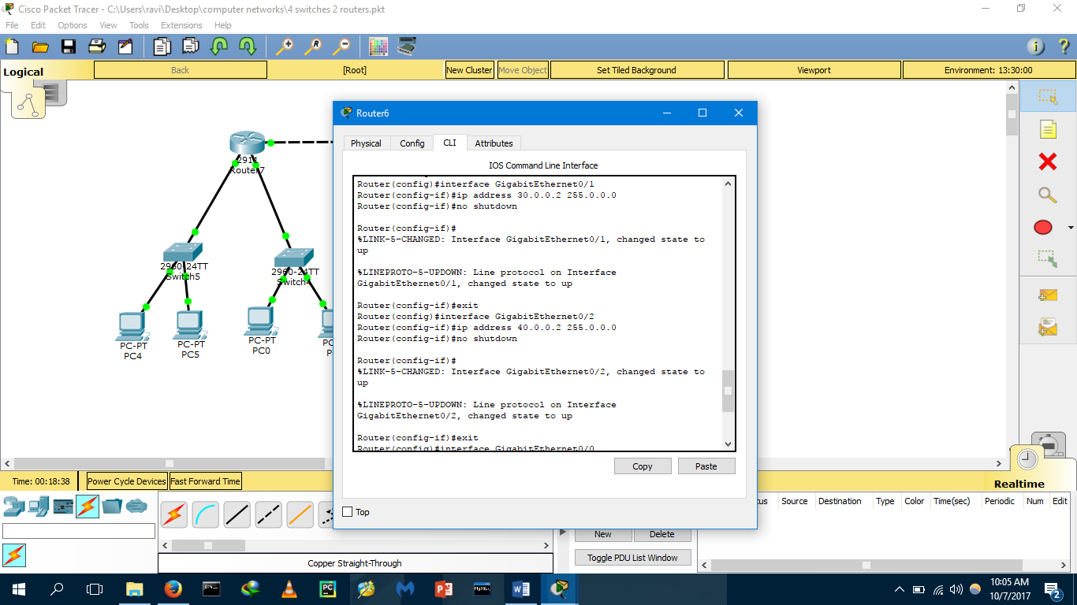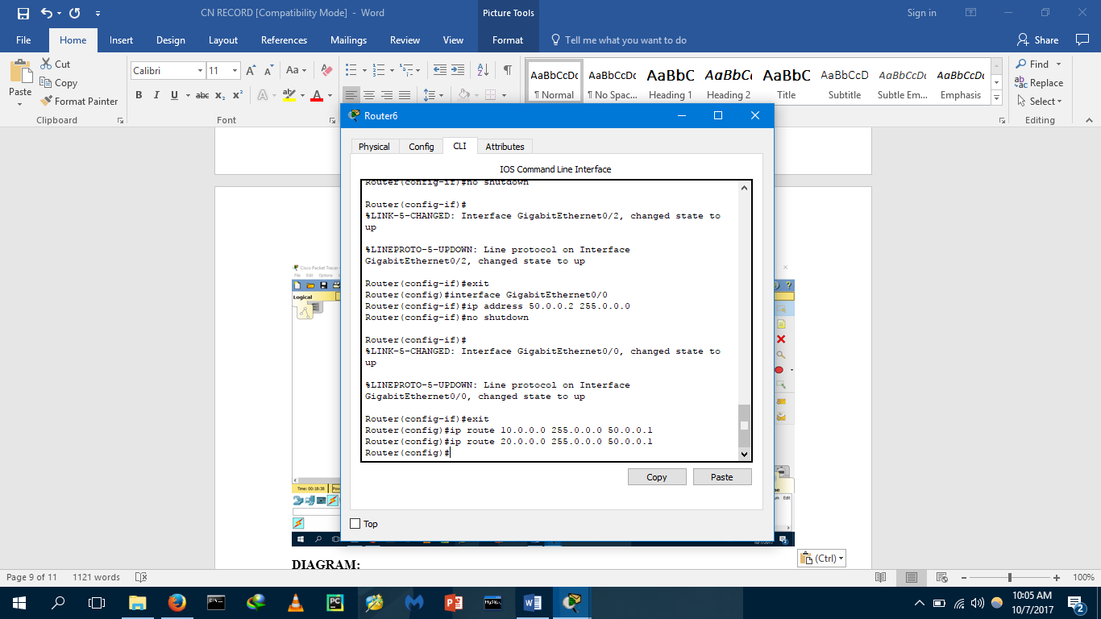

**DIAGRAM:**

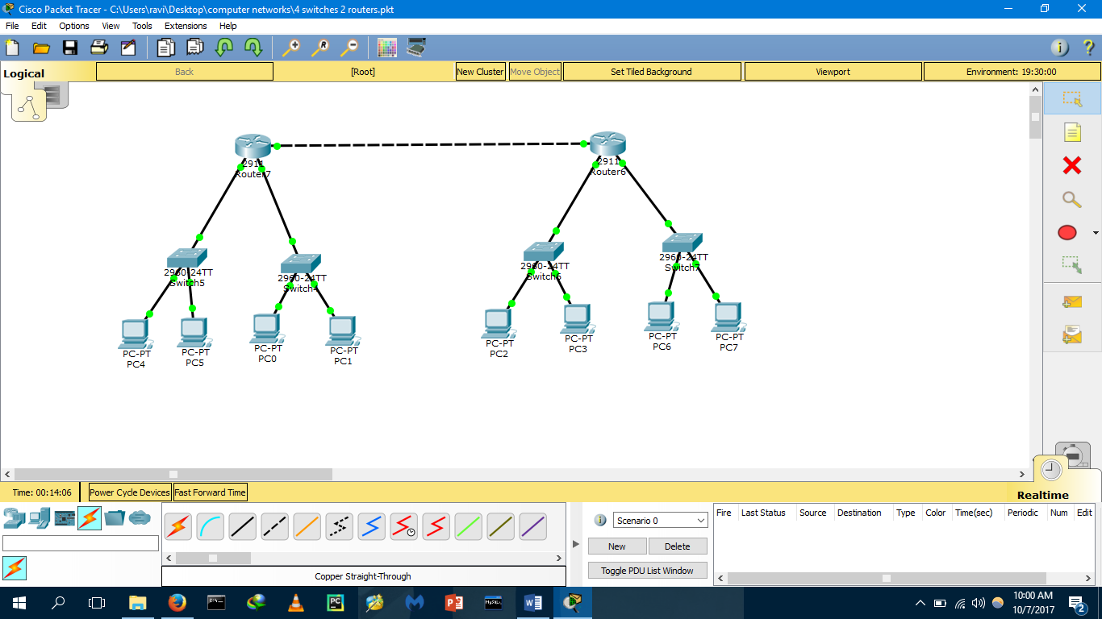

**OUTPUT:**

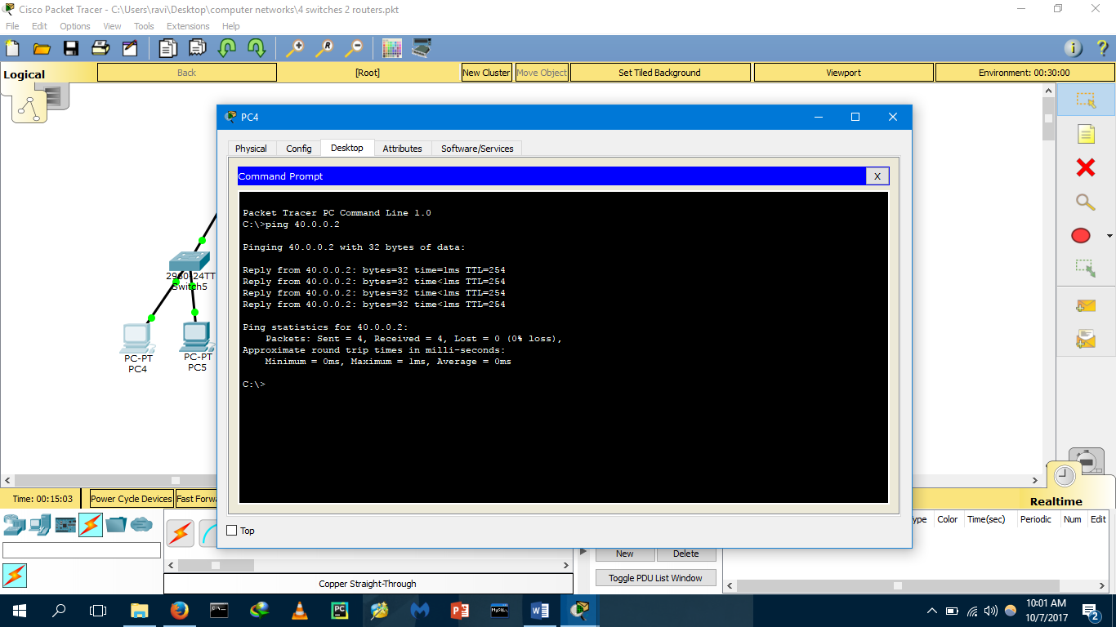

**RESULT:** The LAN connection established successfully.

**EXPERIMENT-4(a)**

**CLASS C SUBNETTING**

**AIM:** To do the subnetting through a router of class C

**PROCEDURE:**

Step1: Click on the packet tracer select two switches, two PCs and two routers.

Step2: Give Ip address of the PCs as 192.168.1.4 and subnet mask as 255.255.255.128 and a gate way as 192.168.1.5 and ip address of the another PC as 192.168.1.8 which are connected to another switch.

Step3: Give the ip address as 192.168.1.135 and subnet mask as 255.255.255.128 and gateway as192.168.1.139 and a ip address of another PC as 192.168.1.142 which are connected to another switch.

Step4: Save the gateway of the PCs in router and check weather the packet gets transferred from one PC to another PC.

**DIAGRAM:**

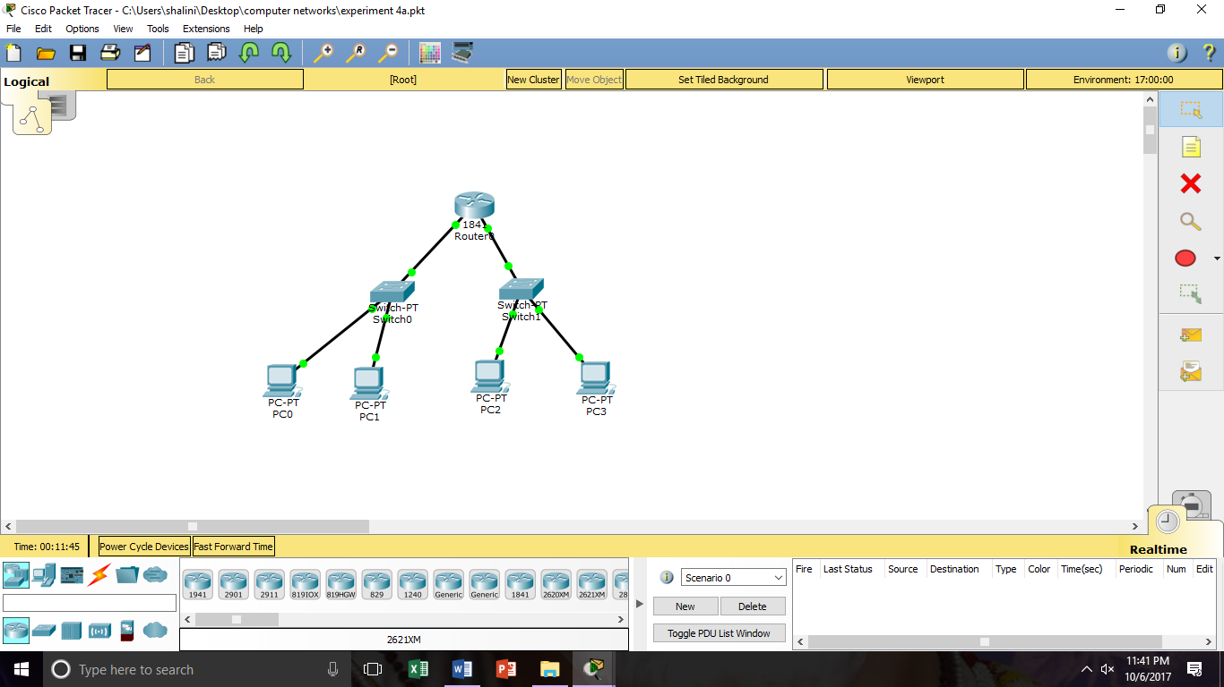

**OUTPUT:**

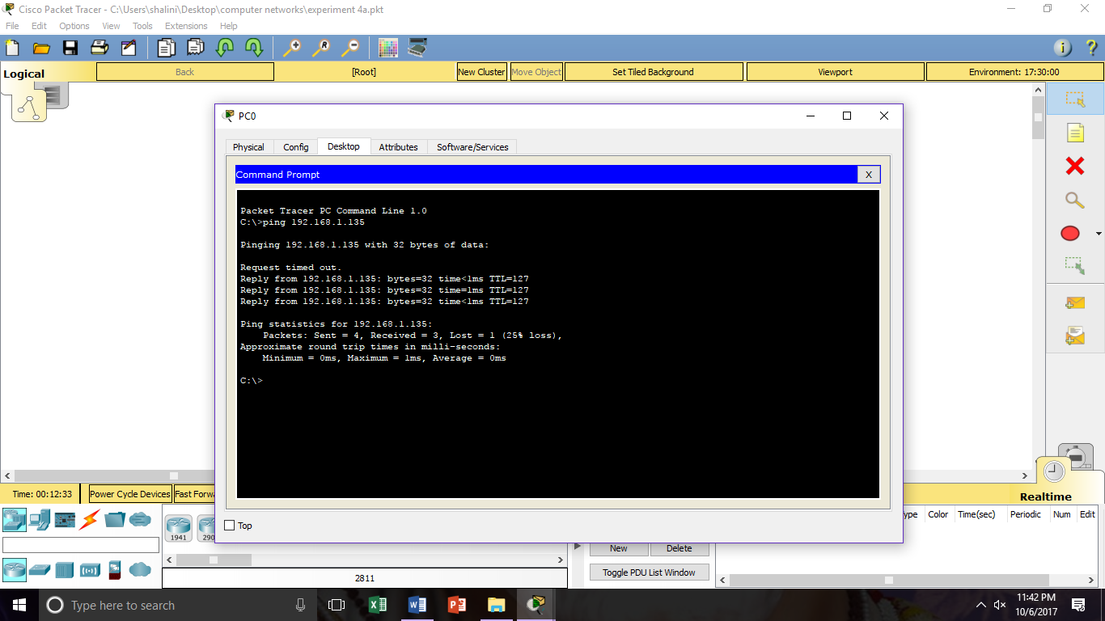P

**RESULT:** The above procedure executed successfully.

**EXPERIMENT-4(b)**

**CLASS B SUBNETTING**

**AIM:** To create a subnetting of class B.

**PROCEDURE:**

Step1: Click on the packet tracer select two switches, two PCs and two routers.

Step2: Give Ip address of the PCs as 172.168.0.1 and subnet mask as 255.255.252.0 and a gate way as 172.168.0.34 and ip address of the another PC as 192.168.1.67 which are connected to another switch.

Step3: Give the ip address as 192.168.4.37 and subnet mask as 255.255.252.0 and gateway as192.168.4.34 and a ip address of another PC as 192.168.5.67 which are connected to another switch.

Step4: Save the gateway of the PCs in router and check weather the packet gets transferred from one PC to another PC.

**DIAGRAM:**

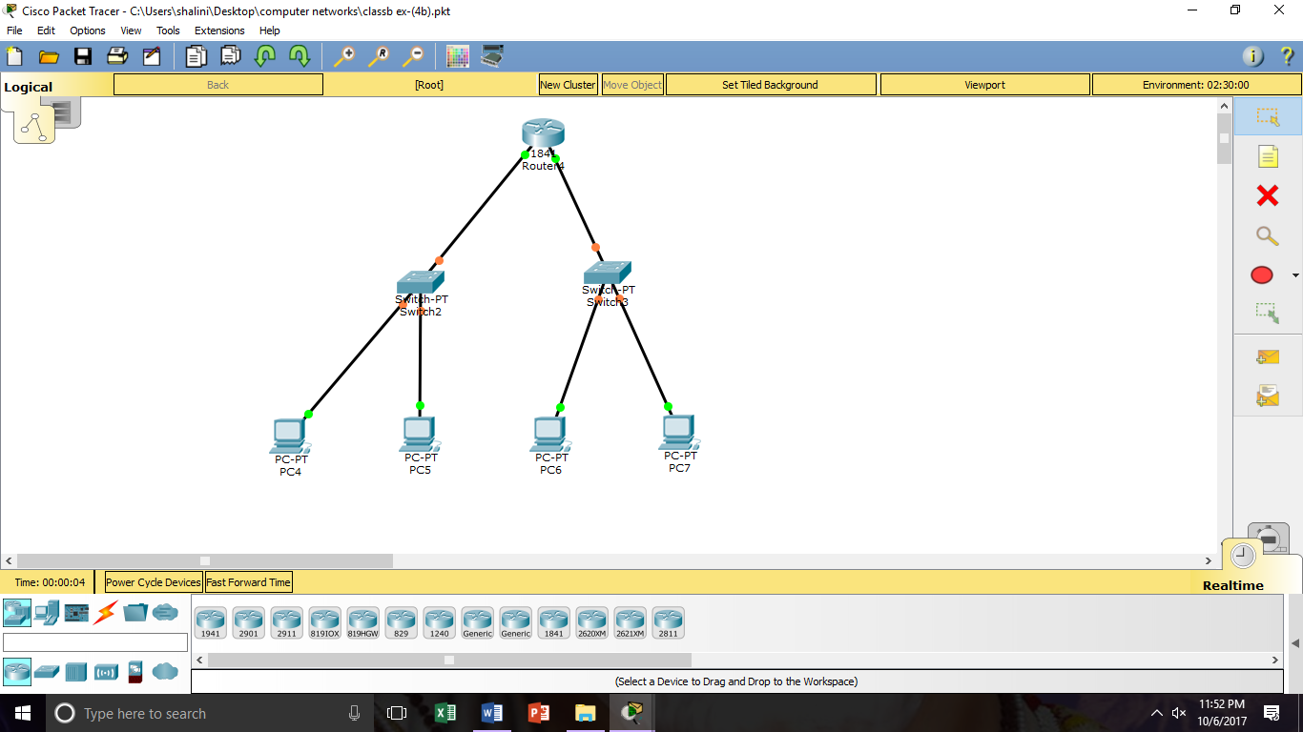

**OUTPUT:**

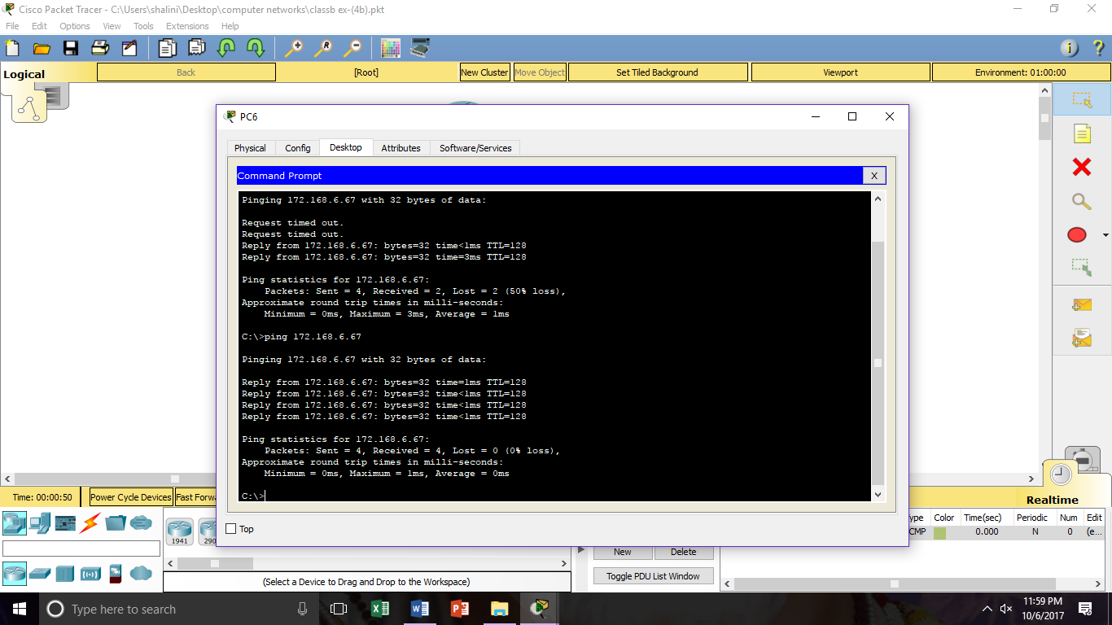

**RESULT:** The above procedure executed successfully.

**EXPERIMENT-4(c)**

**SUBNETTING OF CLASS A**

**AIM:** To create a subnetting of class A.

**PROCEDURE:**

Step1: Click on the packet tracer select two switches, two PCs and two routers.

Step2: Give Ip address of the PCs as 10.0.0.4 and subnet mask as 255.128.0.0 and a gate way as 10.0.0.23 and ip address of the another PC as 10.0.0.5 which are connected to another switch.

Step3: Give the ip address as 10.131.0.37 and subnet mask as 255.128.0.0and gateway as10.130.0.65 and a ip address of another PC as 10.132.0.68 which are connected to another switch.

Step4: Save the gateway of the PCs in router and check weather the packet gets transferred from one PC to another PC.

**DIAGRAM:**

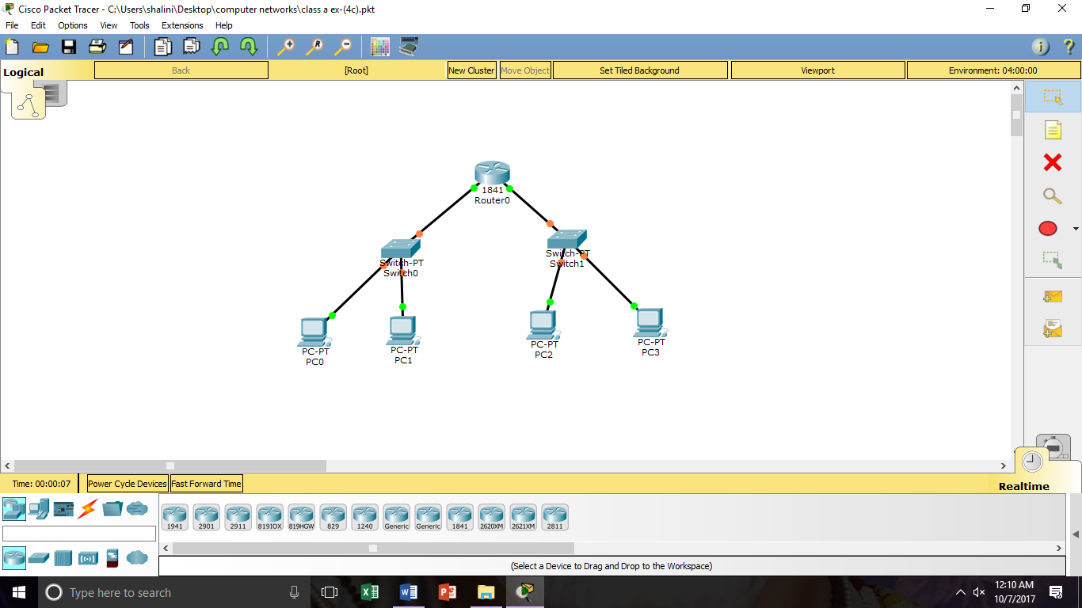

**OUTPUT:**

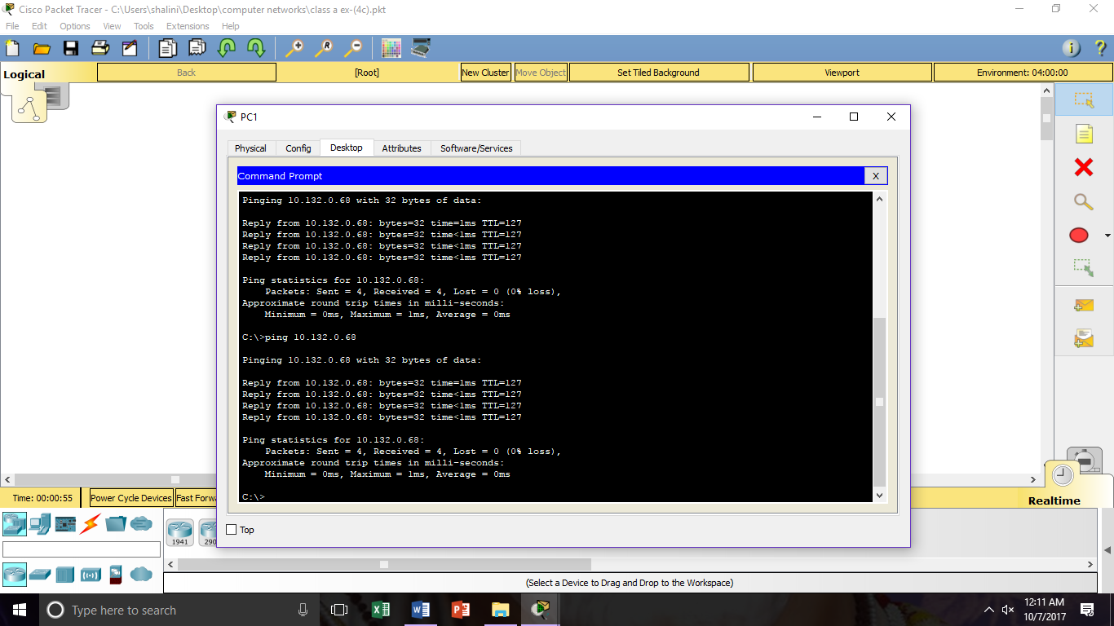

**RESULT:** The above procedure executed successfully.

**EXPERIMENT-5**

**VLSM**

**AIM:** To create VLSM subnetting using class C.

**PROCEDURE:**

Step1: Open the packet tracer and place three routers, three switches and required PCs.

Step2: Now by using serial connection connect three routers.

Step3: Give the ip address as 192.166.8.2/26 and gate way as 192.168.8.1 and another ip address as 192.168.8.5/26 and for serial 2/0 connection give ip address as 192.168.8.161/30 and serial3/0 connection give ip address as 192.168.8.169/30.

Step4: Give the ip address of another PC as 192.168.8.62/26 and 192.168.8.65 as gateway and give ip address of another PC as 192.168.8.69 and give serial2/0 as 192.168.8.162/30 and serial3/0 as 192.168.8.165/30.

Step5: Give the ip address as 192.166.8.8.137/27 and gate way as 192.168.8.129 and another ip address as 192.168.8.130/27 and for serial 2/0 connection give ip address as 192.168.8.166/30 and serial3/0 connection give ip address as 192.168.8.170/30.

Step6: Now go to the router CLI and give following commands

**CLI:**

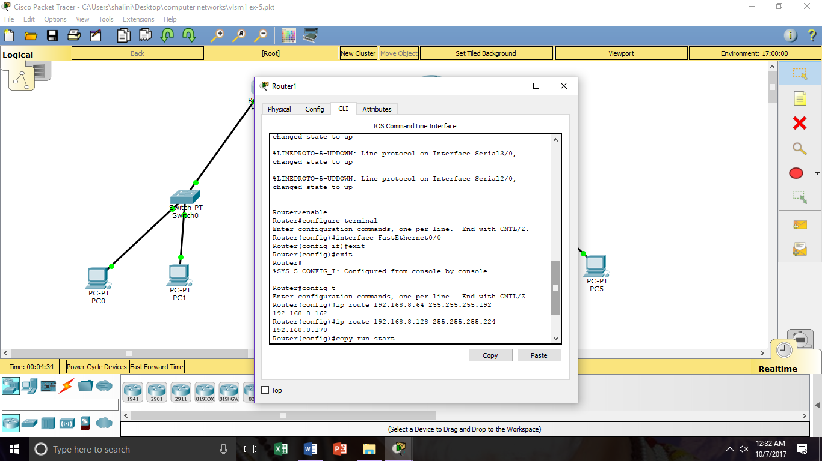

**DIAGRAM:**

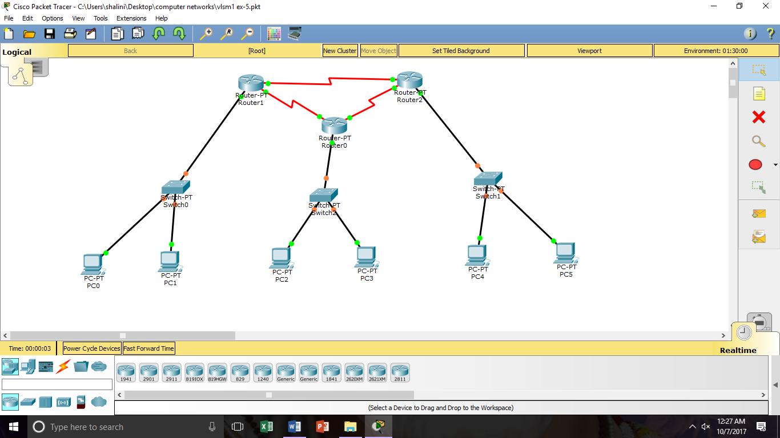

**OUTPUT:**

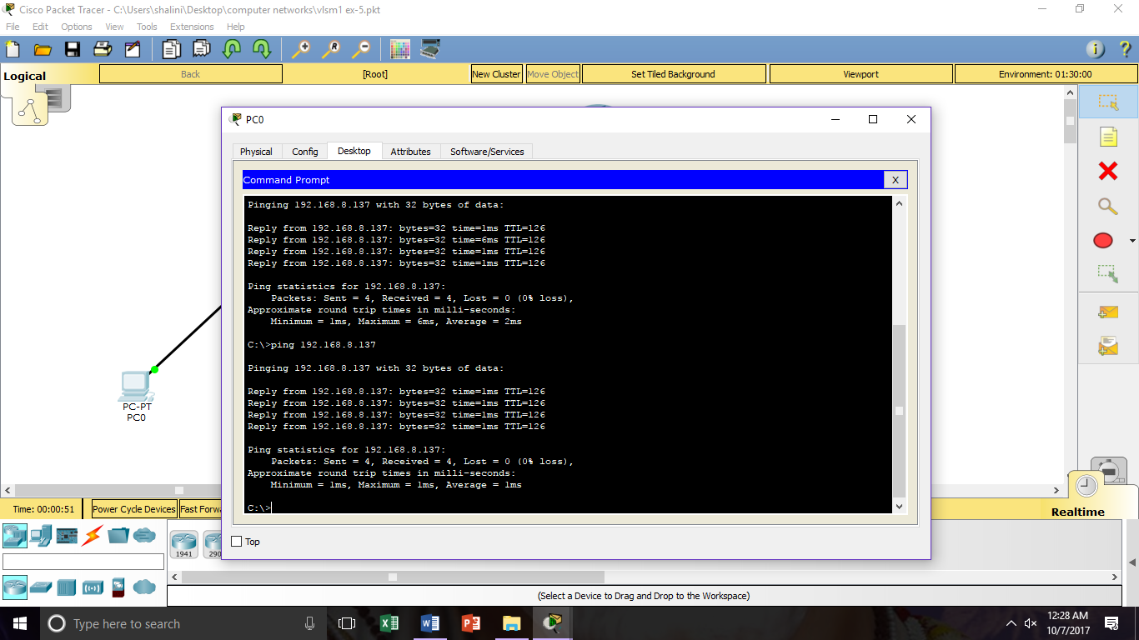

**RESULT:** The above procedure executed successfully.

**EXPERIMENT-6**

**TOPOLOGY**

**BUS TOPOLOGY:**

**AIM:** To create a bus topology using switches.

**PROCEDURE:**

Step1: Click on packet tracer place required switches and connect them with copper-cross through wire.

Step2: Now connect required PCs to the switches and assign required ip address to each PC .Give ipaddress of PC0 as 10.0.0.2/8 and subnet mask as 255.0.0.0 and gateway as 10.0.0.1.

Step3: Now go to the PC1 and assign ipaddress as 10.0.0.3/8 and PC2 as 10.0.0.4/8 and required subnet mask as 255.0.0.0 and gateway as 10.0.0.1

Step4: Now go the PC0 and to desktop, to command prompt and give the ping command and the corresponding ip address of the PC2 and check weather the packet is able to reach from one PC to another.

**DIAGRAM:**

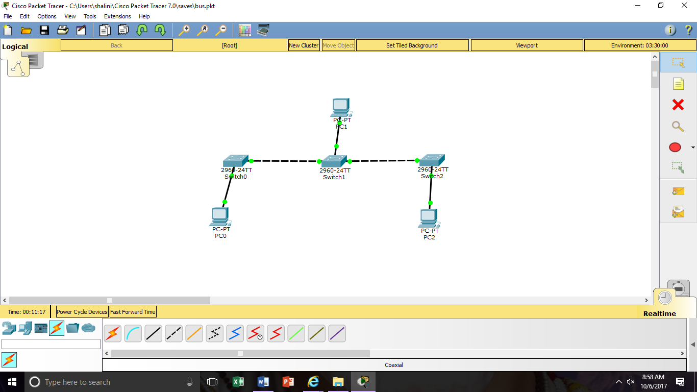

**OUTPUT:**

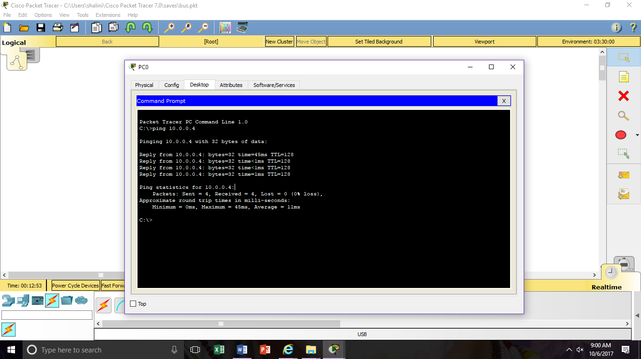

**RESULT**: The above procedure executed successfully.

**STAR TOPOLOGY**

**AIM:** To create a star topology using switch.

**PROCEDURE:**

Step1: Click on packet tracer place required switches and connect them with copper straight through wire.

Step2: Now place the required no of PCs and connect to the switch with copper- straight through now assign the required ip address to the PC0 as 10.0.0.4, PC1 as 10.0.0.5, PC2 as 10.0.0.2 ,PC3 as 10.0.0.6 and PC4 as 10.0.0.3 and the gateway of the above PCs as 10.0.0.1.

Step3: Now go to the PC0 ,to desktop and to the command prompt and give the command ping with the corresponding ipaddress of the PC2.

Step4: Now weather the packet is able to reach the other PC.

**DIAGRAM:**

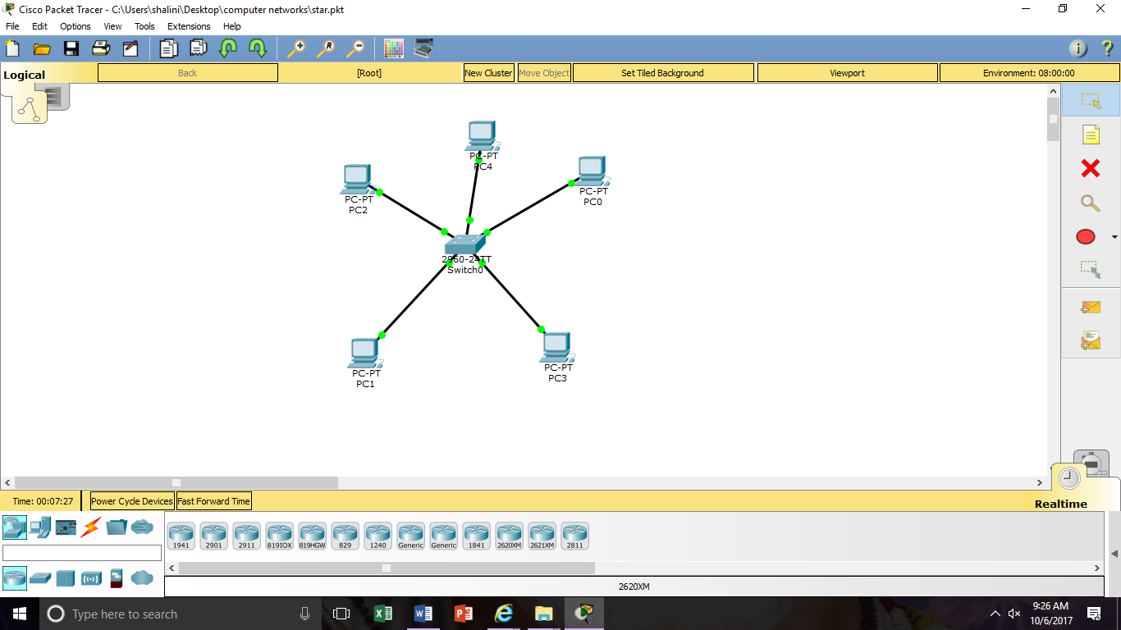

**OUTPUT:**

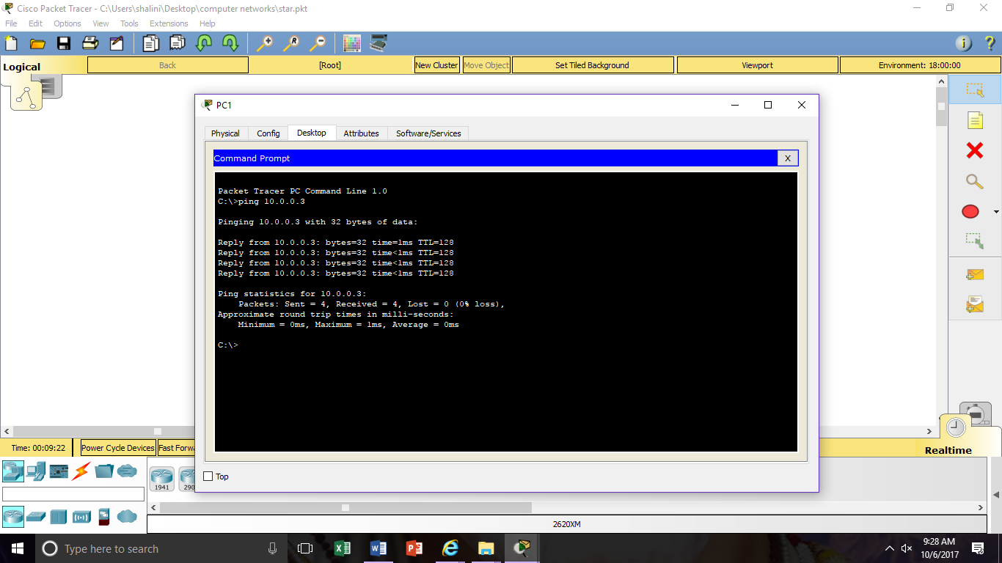

**RESULT**: The above procedure executed successfully.

**RING TOPOLOGY**

**AIM:** To create ring topology using switches.

**PROCEDURE:**

Step1: Click on packet tracer place required switches and connect them with copper- cross through wire.

Step2: Now place the required number of PCs and connect to the switches with copper-straight through wire and assign the ip address of the PC0, PC1, PC2, PC3 as 10.0.0.2, 10.0.0.3, 10.0.0.4,10.0.0.5 and the gateway as 10.0.0.1.

Step3: Now go PC0 ,to desktop ,to command prompt and give the command ping with the required ip address of any PC.

Step4: Now check weather the packet able to reach from one PC to another PC.

**DIAGRAM:**

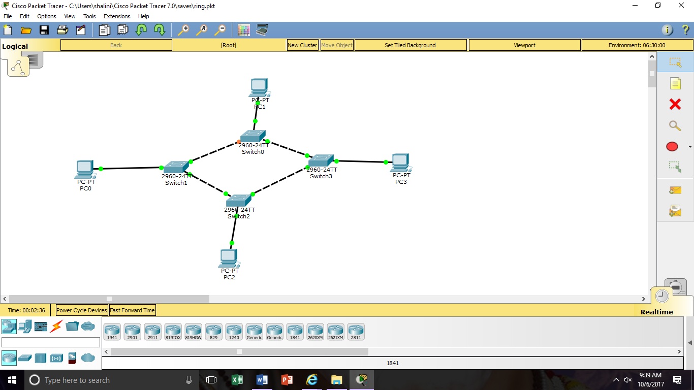

**OUTPUT:**

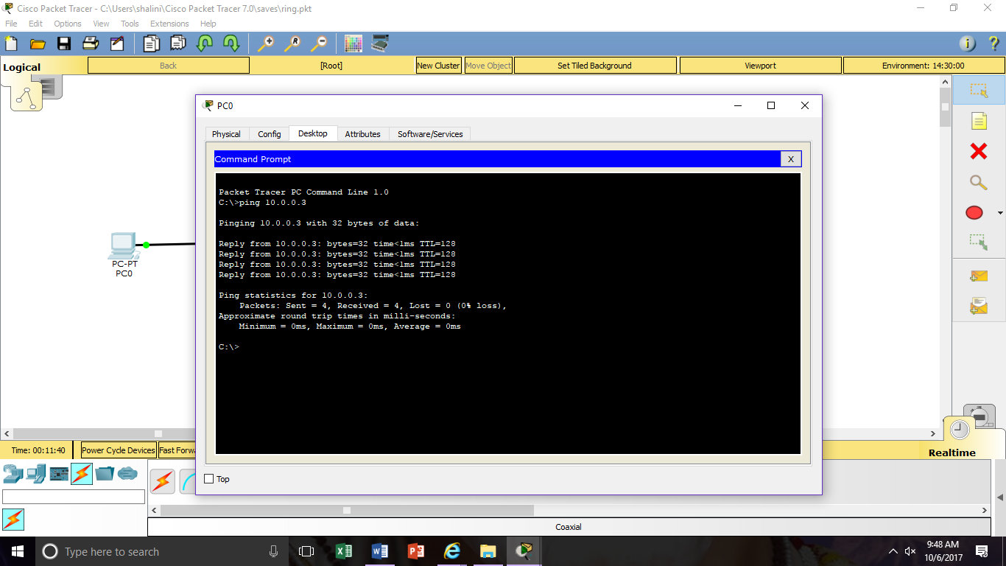

**RESULT:** The above procedure executed successfully.

**MESH TOPOLOGY**

**AIM:** To create the mesh topology with switches.

**PROCEDURE:**

Step1: Click on packet tracer place required switches and connect them with copper- cross through wire.

Step2:Now connect the required PCs with the copper-straight through wire to the switch and give the Ip address of the PC0,PC1,PC2,PC3,PC4 as 10.0.0.2,10.0.0.3,10.0.0.4,10.0.0.5,10.0.0.6 and the required gateway as 10.0.0.1.

Step3:Now go to one PC to desktop, to command prompt and give the command as ping with the required ip address of the another PC.

Step4: Now check weather the packet is able to reach another PC.

**DIAGRAM:**

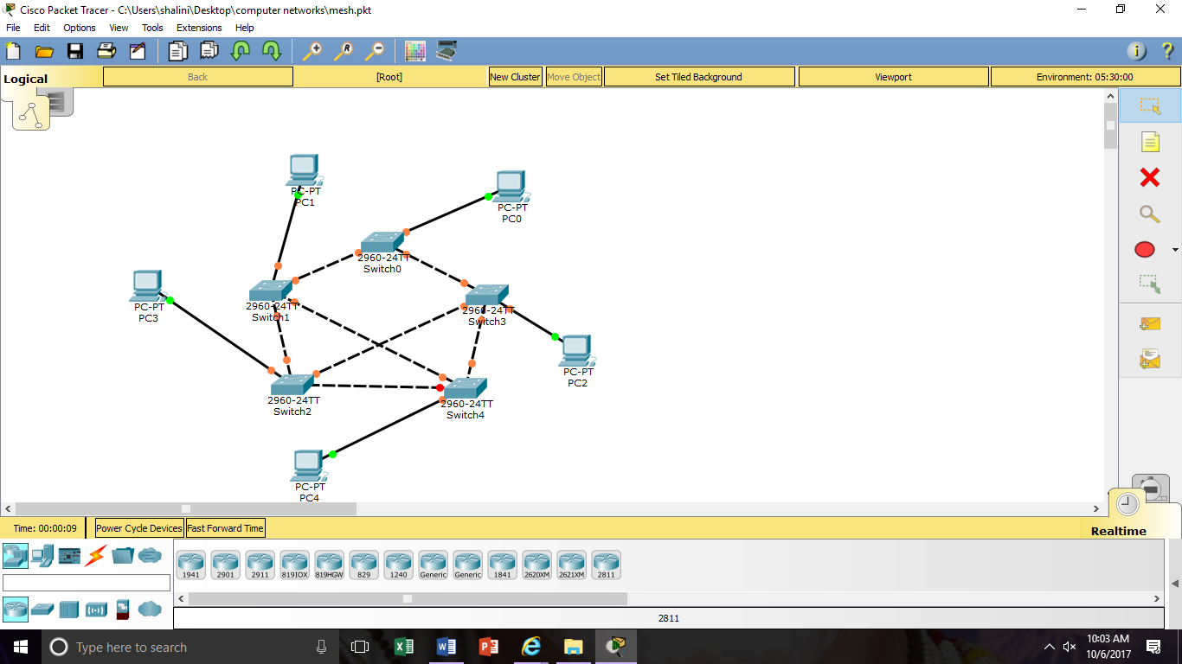

**OUTPUT:**

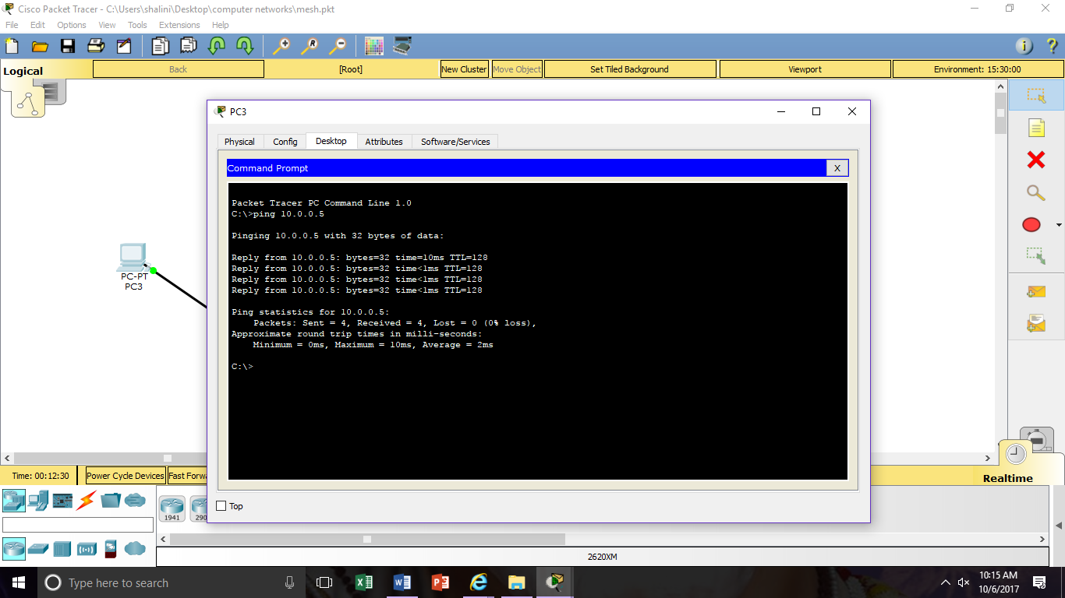

**RESULT**: The above procedure executed successfully.

**EXPERIMENT-7**

**CREATING A PASSWORD TO A ROUTER**

**AIM:** To create a password to a router when connected to the PC.

**PROCEDURE:**

Step1: Click on packet tracer place router and connect PC with copper- cross through wire.

Step2: Now assign a Ip address to the PC as 192.168.10.2 and subnet mask as 255.255.255.0.

Step3: Now go the router in CLI give the following commands.

Step4: Now after giving the required commands now go the PC, to desktop, to command prompt and give telnet command with gateway.

Step5: Now give corresponding username and password and proceed with the experiment.

**DIAGRAM:**

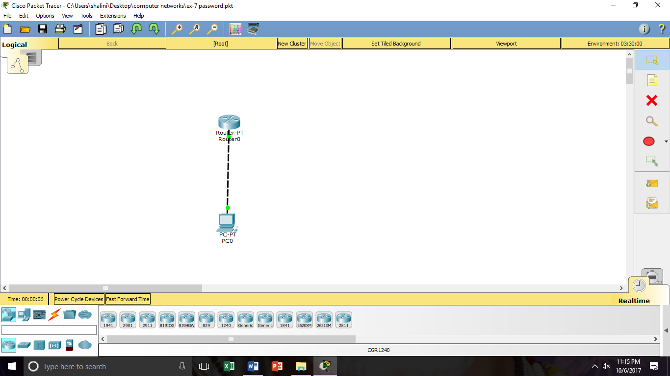

**CLI:**

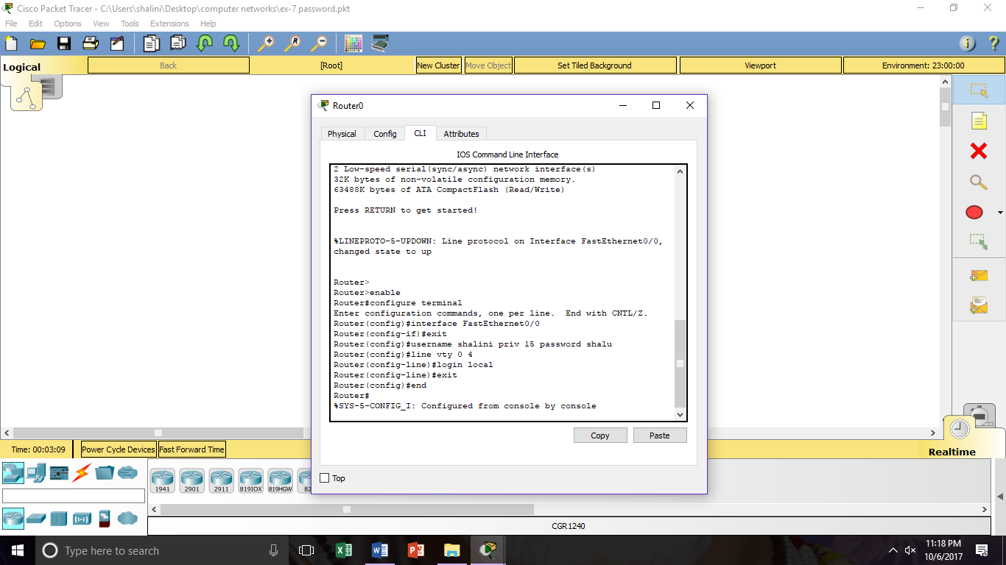

**OUTPUT:** 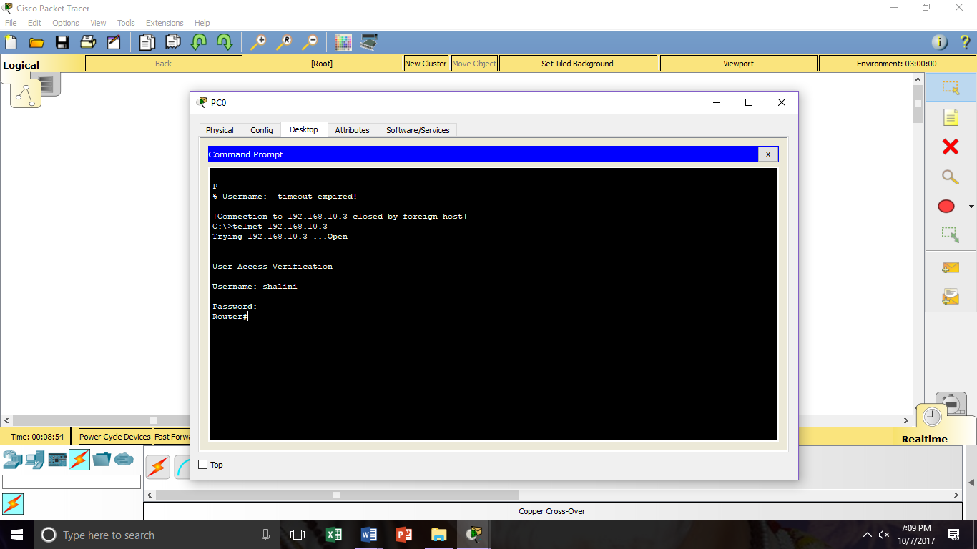

**RESULT** : The above procedure executed successfully.

**EXPERIMENT-8**

**RIP VERSION1**

**AIM:** To create a RIP version1.

**PROCEDURE:**

Step1: Click on the packet tracer and place the required number of routers and number of PCs.

Step2: Connect two routers with serial connection and PCs with copper-cross wire.

Step3: Now assign values or ip address for PCs 192.168.2.1 and another PC as 192.168.1.4/24 and gateway as 192.168.2.2.

Step4: And for a router 192.168.3.2/24 and 192.168.3.3/24 for another router by the serial connection.

Step5: Now go to the RIP and add networks as 192.168.1.0 , 192.168.2.0 and 192.168.3.0 in both routers.

Step6: Now see weather the packet is transfer to one to another.

**DIAGRAM:**

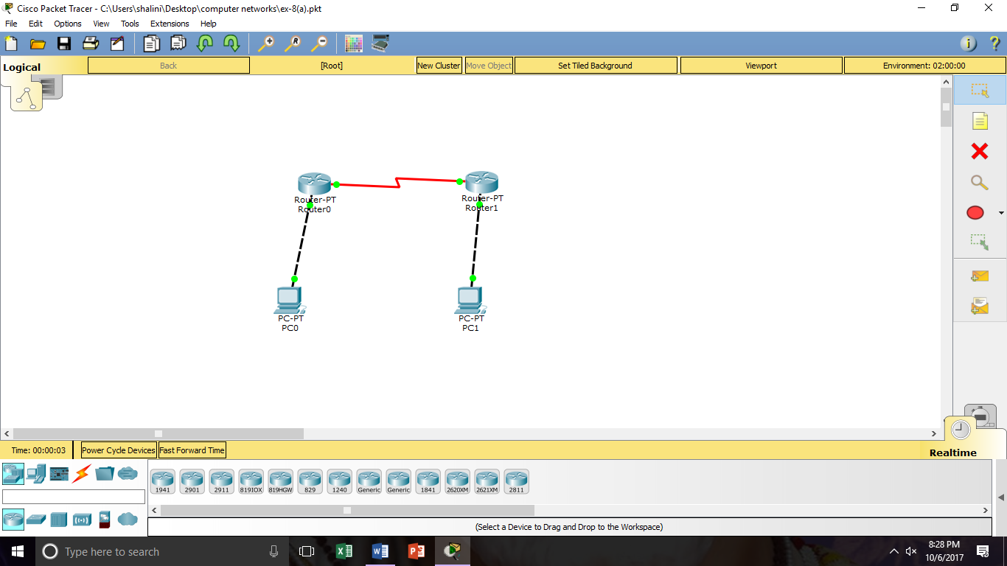

**OUTPUT:**

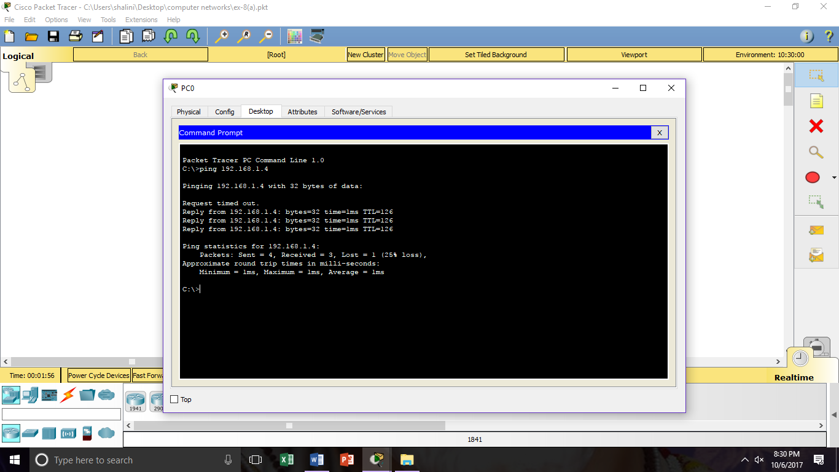

**RESULT:** The above procedure executed successfully.

**EXPERIMENT-8(b)**

**RIP VERSION2**

**AIM :** To create a rip version 2 using crosswire.

**PROCEDURE:**

Step1: Open the packet tracer place the required number of PCs and the routers.

Step2: Now connect two routers with serial connection, and connect PC to switches with copper-straight wire and to routers with copper-strainght wire.

Step3: Now assign the ip address of the PCs as 192.168.8.5/26 and gateway as 192.168.8.32 and subnet mask as 255.255.255.192 and another PC as 192.168.8.45/26.

Step4: Now assign the another PCs ip address as 192.168.8.80/27 and gateway as 192.168.8.92 and subnet mask as 255.255.255.192 and another PC as 192.168.8.92.

Step5: Now give ip address in router1 as 192.168.8.97/30 and subnet mask as 255.255.255.252

and another ip address as 192.168.8.98/30 and subnet mask as 255.255.255.252.

Step6: Now go to router1 in CLI give commands as follows.

**DIAGRAM:**

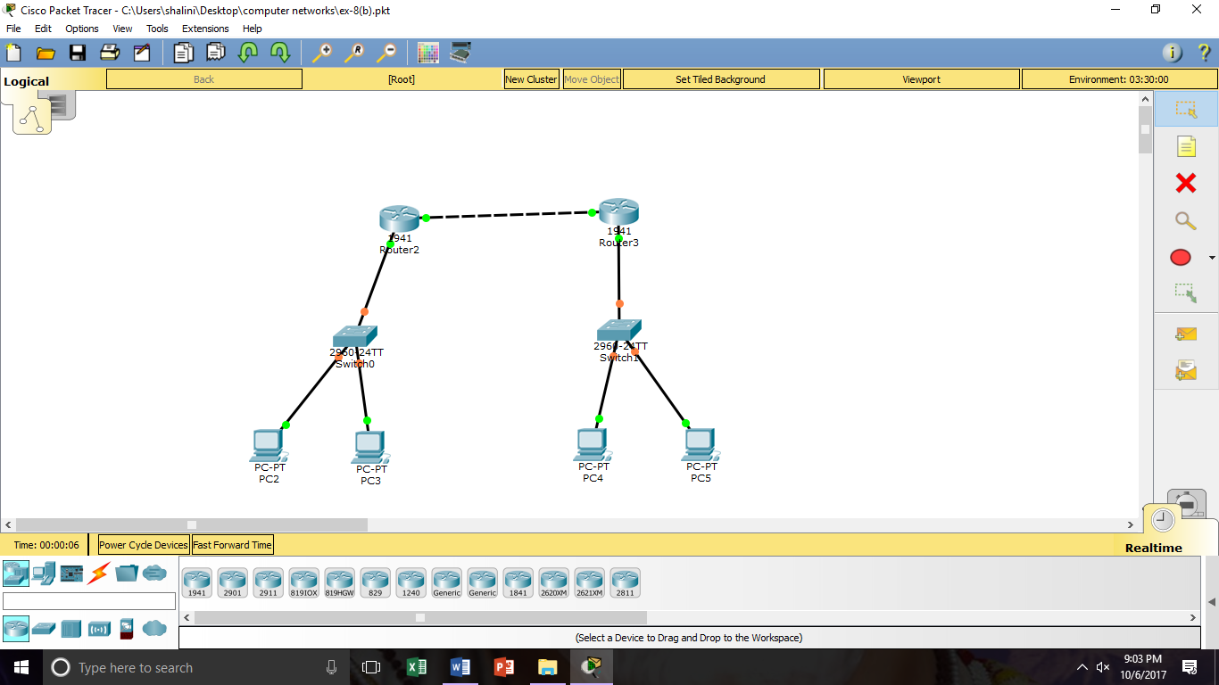

**CLI /OUTPUT:**

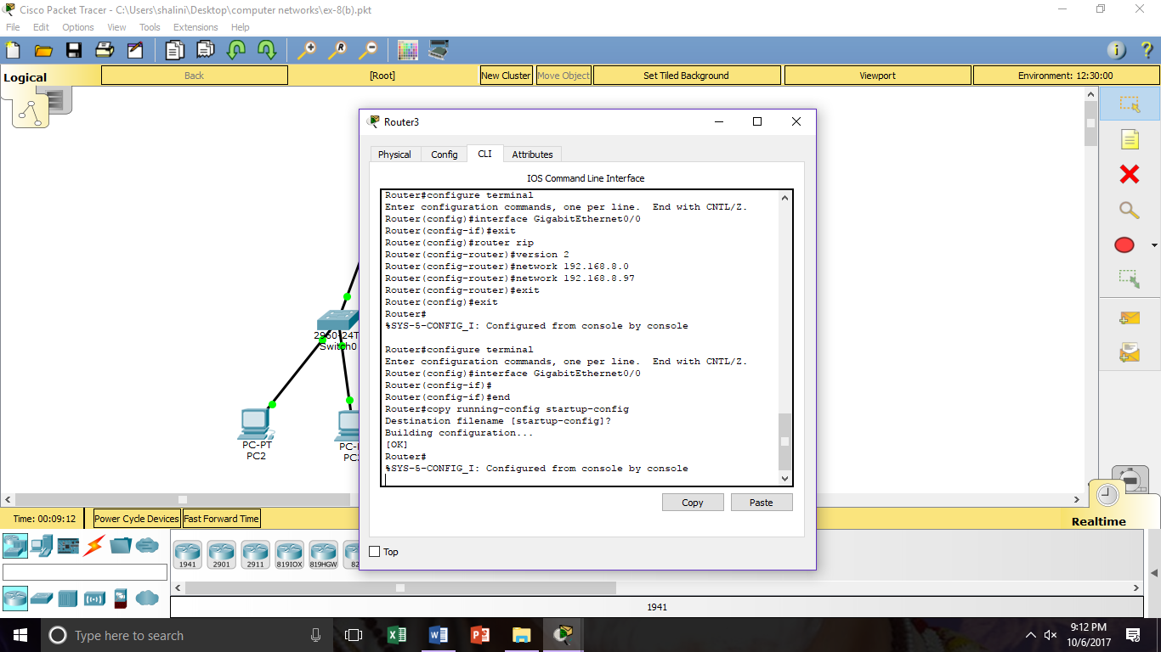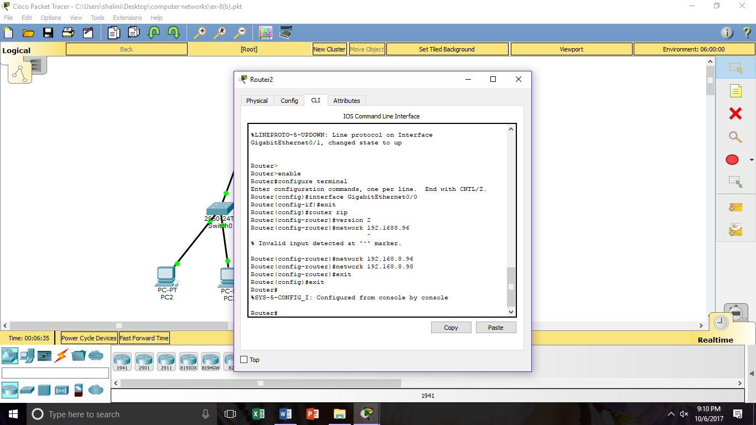

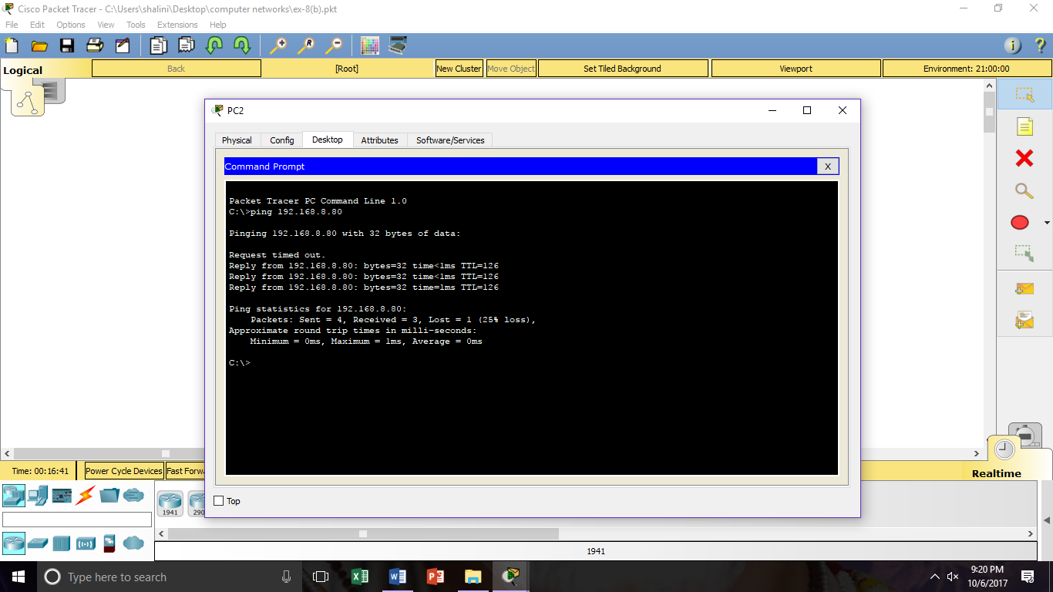

**RESULT:** The above procedure executed successfully.

**EXPERIMENT-9**

**OSPF ROUTE SUMMARIZATION**

**AIM:** To create a OSPF summarization route.

**PROCEDURE:**

Step1: Open packet tracer and place generic routers with two routers.

Step2: Give the ip address and gateway of router1 as 192.168.0.3/24 and the another router as 192.168.1.3/24 and connect the two routers with the generic router with fastethernet 0/0 and fastethernet 1/0 as 192.168.0.4/24 and 192.168.1.4/24.

Step3: Now connect the generic router with another generic router by serial 2/0 10.0.0.1/30 in one PC and 10.0.0.2/30 in another PC.

Step4: Now go to the router1 CLI and give commands as follows.

**DIAGRAM:**

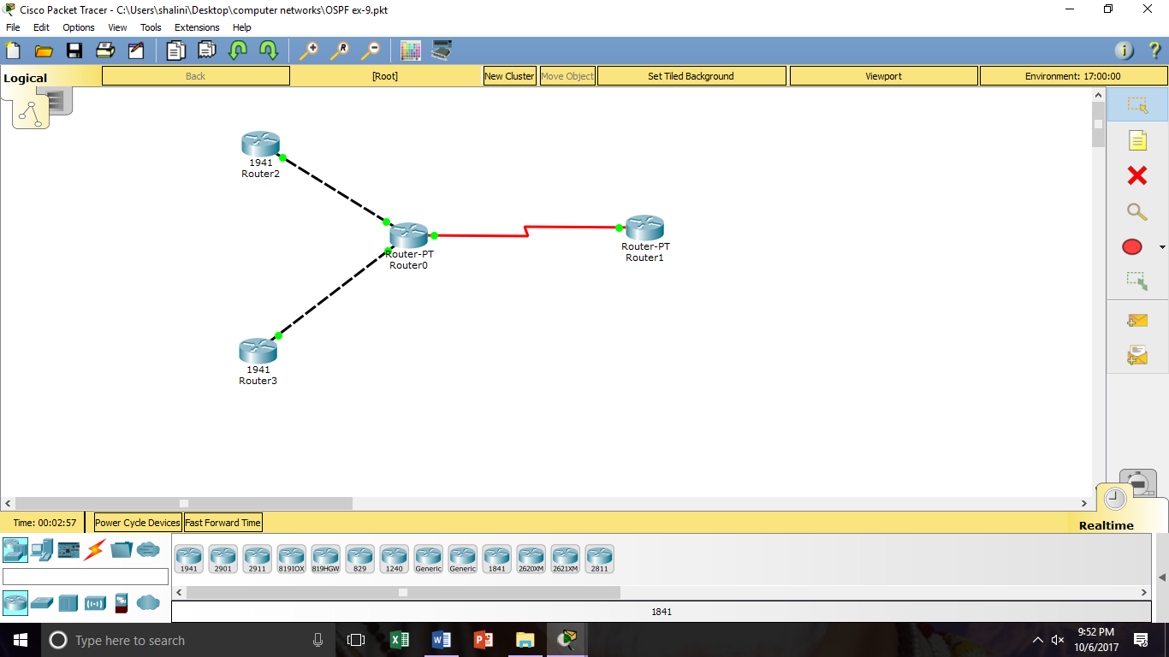

**OUTPUT:**

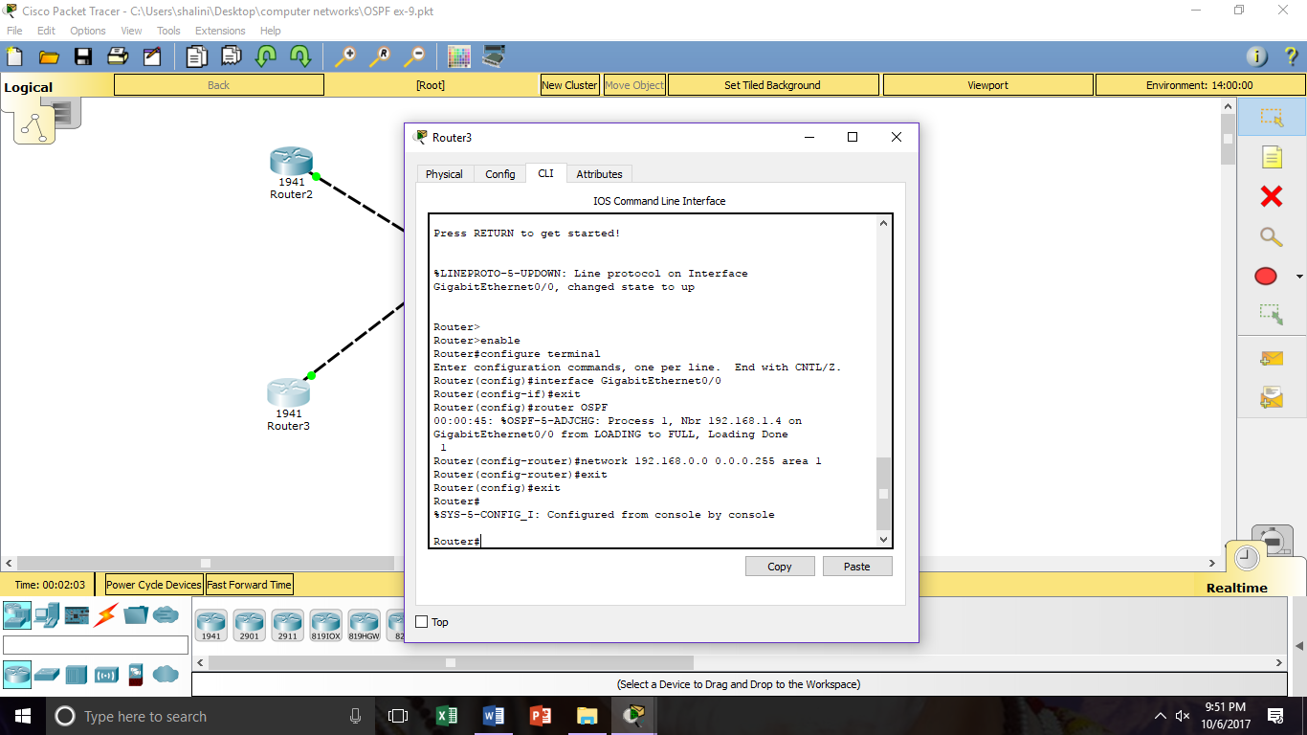

**RESULT**: The above procedure executed successfully.

**EXPERIMENT- 9(b)**

**SUMMARIZATION**

**AIM:** To create supernetting (or) summarization.

**PROCEDURE:**

Step1: Open the packet tracer and place router, three switches and required number of PCs.

Step2: Now aasign the ip address of PC1 as 192.168.0.2/21 and subnet mask as 255.255.248.0 and gateway as 192.168.0.5 and another PC2 as 192.168.0.8/21 these are connected to another switch.

Step3: Now assign the ip address of PC# as 192.168.8.3/21 and subnet mask as 255.255.248.0 and the gateway as 192.168.8.5 and ip address of PC4 as 192.168.8.4/21 these are connected to another switch.

Step4: Now assign the ip address od PC5 as 192.168.17.3/21 and subnet mask as 255.255.255.248.0 and the gateway as 192.168.17.5 and ipaddress of PC6 as 192.168.17.4/21 these are connected to another switch.

Step5: Now check weather the packet is transferred from one PC to another PC.

**DIAGRAM:**

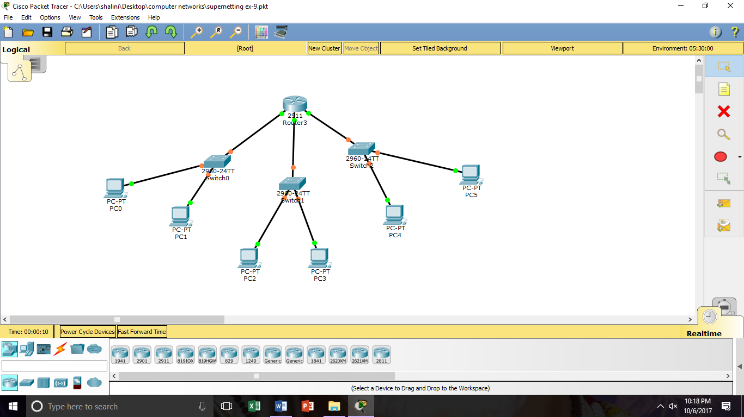

**OUTPUT:**

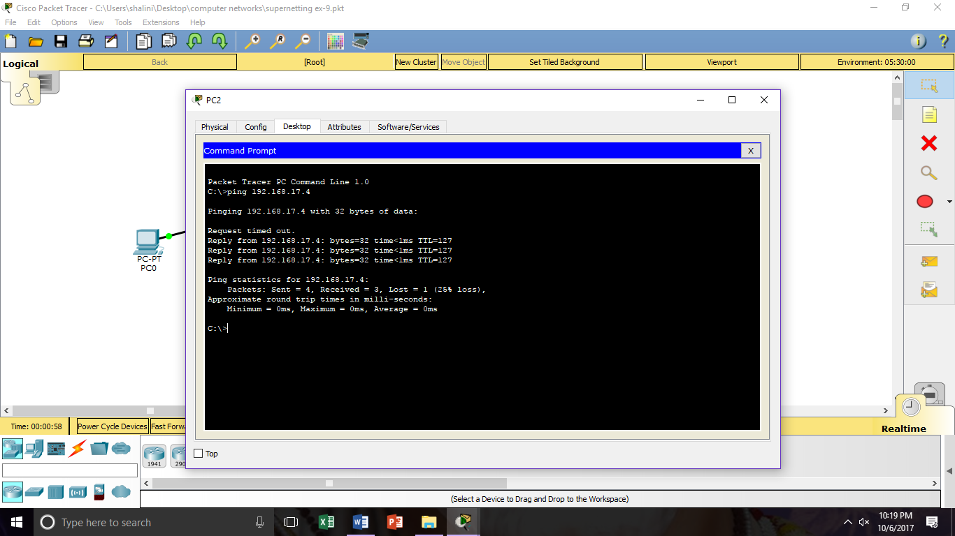

**RESULT:** The above procedure executed successfully.

**EXPERIMENT-10**

**EIGRP**

**AIM:** To implement EIGRP using CICSCO packet tracer.

**PROCEDURE:**

Step1:Place the required no of routers ,switches and PCs on the console.

Step2: Now give the iip address of PC0 as 192.168.10.2/24 and the gateway as 192.168.10.1 subnet mask as 255.255.255.0.

Step3: Now PC1 as 192.168.10.1 subnet mask as 255.255.255.0 and PC2 as 192.168.30.3 and gateway as 192.168.10.1 and PC3 as 192.168.30.2.

Step4: Now save the corresponding gateway in the router and assign ipaddress of the router as 192.168.20.2 and subnet mask as 255.255.255.0 and clockrate as 128000 and another router as 192.168.20.1.

Step5: Now go to the CLI and give the following commands.

**DIAGRAM:**

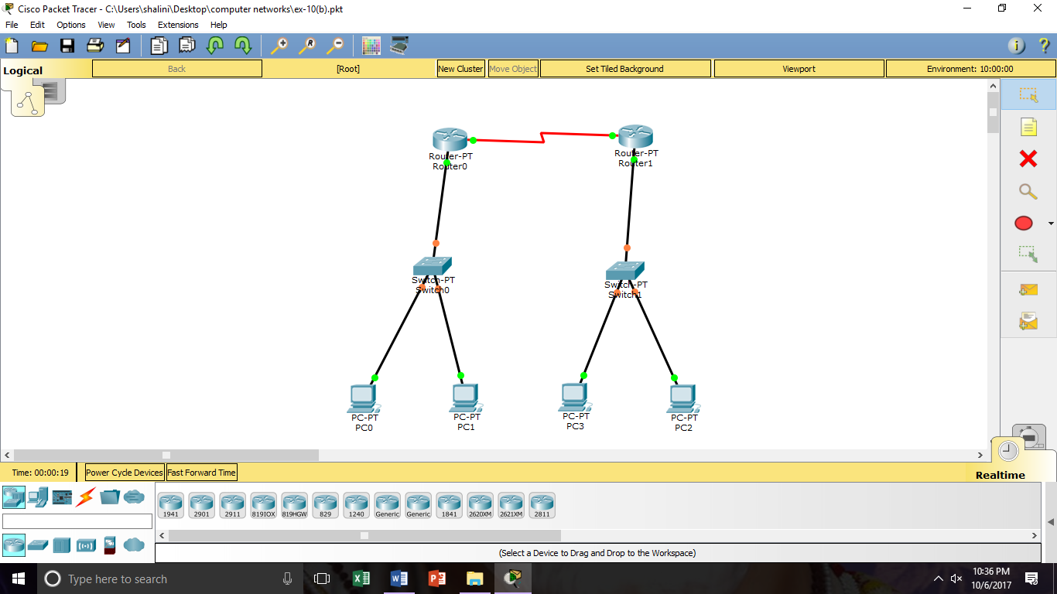

**DIAGRAM:**

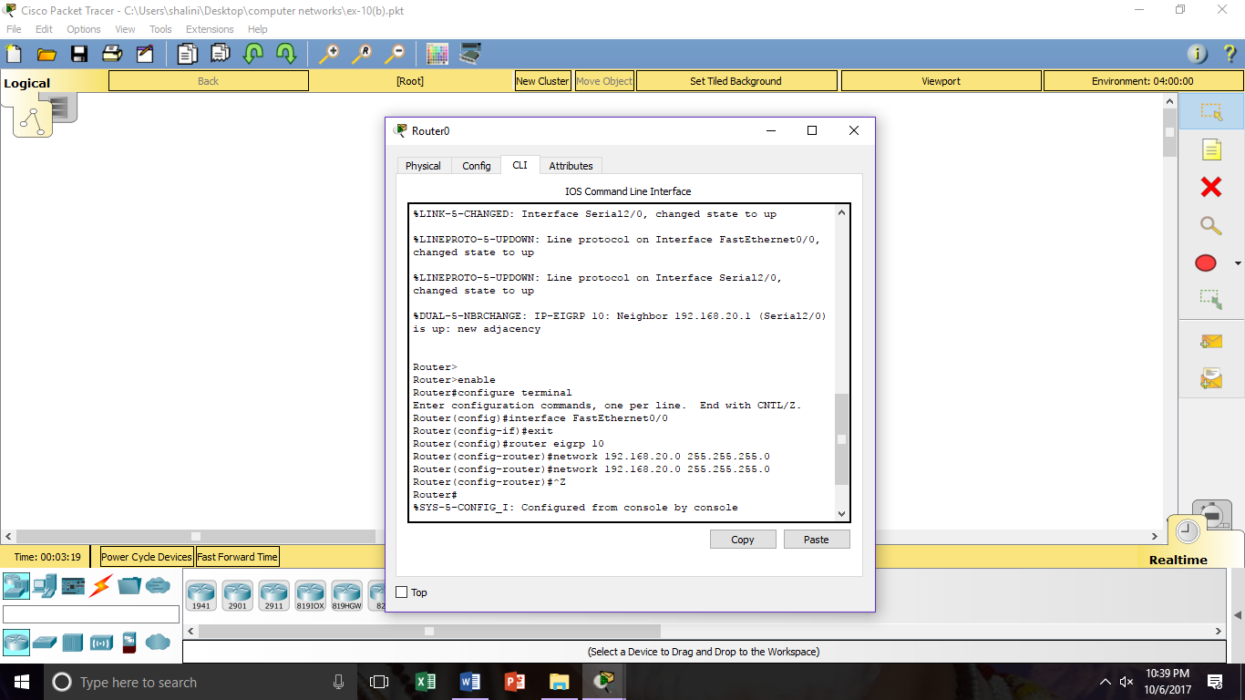

**OUTPUT:**

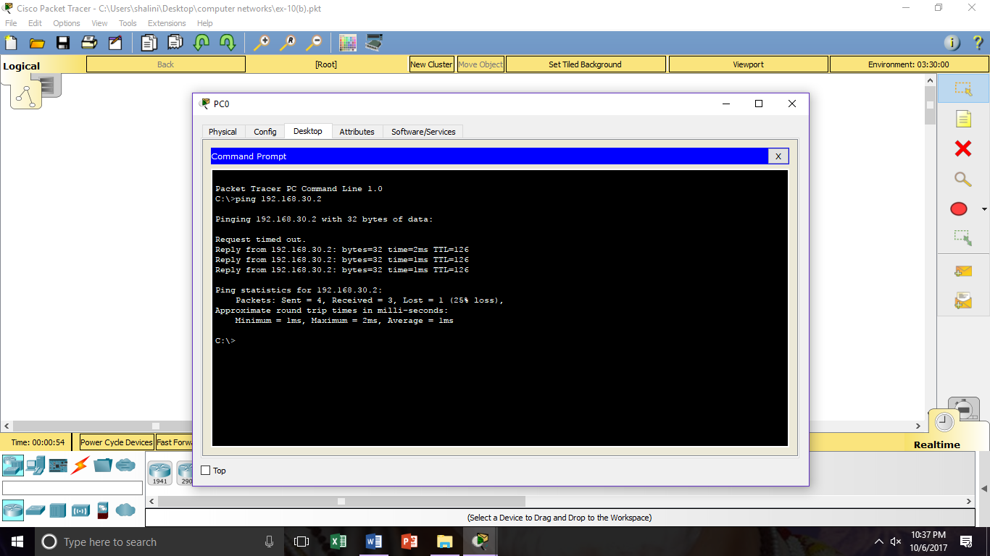

**RESULT**: The above procedure executed successfully.